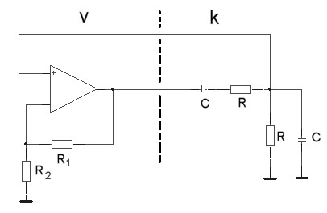

$\underline{k}=\frac{jϖ\text{CR}}{−C^{2}R^{2}ϖ^{2}+1+3jϖ\text{RC}}$ für: $\begin{aligned}−C^{2}R^{2}ϖ^{2}+1=0;\text{arc}(\underline{k})=0° \\ \end{aligned}$
$ϖ_{0}=\frac{1}{\sqrt{\text{CR}}}$
$$k(ϖ_{0})=\frac{1}{3}⇒v=3$$

