[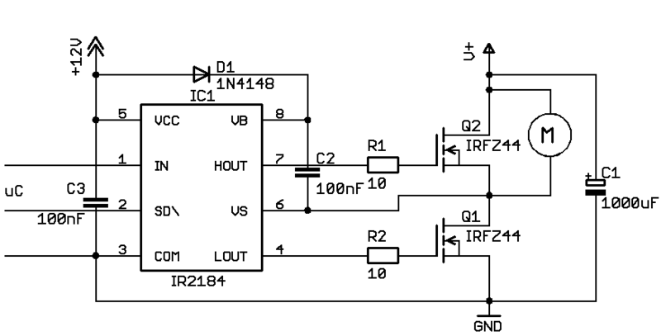](http://www.mikrocontroller.net/wikifiles/0/0d/Motor_PWM2_real.gif)