Circuit diagram:
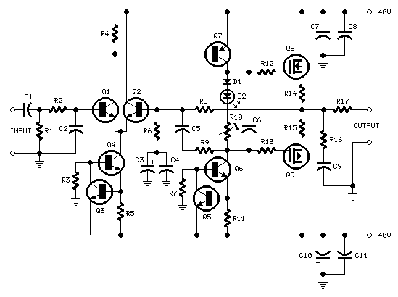

Parts:
R1______________47K 1/4W Resistor
R2_______________4K7 1/4W Resistor
R3______________22K 1/4W Resistor
R4_______________1K 1/4W Resistor
R5,R12,R13_____330R 1/4W Resistors
R6_______________1K5 1/4W Resistor
R7______________15K 1/4W Resistor
R8______________33K 1/4W Resistor
R9_____________150K 1/4W Resistor
R10____________500R 1/2W Trimmer Cermet
R11_____________39R 1/4W Resistor
R14,R15___________R33 2.5W Resistors
R16_____________10R 2.5W Resistor
R17_______________R22 5W Resistor (wirewound)

C1_____________470nF 63V Polyester Capacitor
C2_____________470pF 63V Polystyrene or ceramic Capacitor
C3______________47µF 63V Electrolytic Capacitor
C4,C8,C9,C11___100nF 63V Polyester Capacitors
C5______________10pF 63V Polystyrene or ceramic Capacitor
C6_______________1µF 63V Polyester Capacitor
C7,C10_________100µF 63V Electrolytic Capacitors

D1___________1N4002 100V 1A Diode
D2_____________5mm. Red LED

Q1,Q2,Q4_____MPSA43 200V 500mA NPN Transistors
Q3,Q5________BC546 65V 100mA NPN Transistors
Q6___________MJE340 200V 500mA NPN Transistor
Q7___________MJE350 200V 500mA PNP Transistor
Q8___________IRFP240 200V 20A N-Channel Hexfet Transistor
Q9___________IRFP9240 200V 12A P-Channel Hexfet Transistor

Power supply circuit diagram:
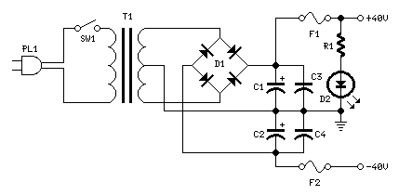

Parts:
R1_______________3K9 1W Resistor

C1,C2_________4700µF 63V Electrolytic Capacitors (See Notes)
C3,C4__________100nF 63V Polyester Capacitors

D1_____________400V 8A Diode bridge
D2_____________5mm. Red LED

F1,F2__________4A Fuses with sockets

T1_____________230V or 115V Primary, 30+30V Secondary 160VA Mains transformer

PL1____________Male Mains plug

SW1____________SPST Mains switch

Comments:
To celebrate the hundredth design posted to this website, and to fulfil the requests of many correspondents wanting an amplifier more powerful than the 25W MosFet, a 60 - 90W High Quality power amplifier design is presented here.
Circuit topology is about the same of the above mentioned amplifier, but the extremely rugged IRFP240 and IRFP9240 MosFet devices are used as the output pair, and well renowned high voltage Motorola's transistors are employed in the preceding stages.
The supply rails voltage was kept prudentially at the rather low value of + and - 40V. For those wishing to experiment, the supply rails voltage could be raised to + and - 50V maximum, allowing the amplifier to approach the 100W into 8 Ohm target: enjoy!
A matching, discrete components, Modular Preamplifier design is available here: Modular Audio Preamplifier.

Notes:
- In the original circuit, a three-diode string was wired in series to R10. Two of these diodes are now replaced by a red LED in order to achieve improved quiescent current stability over a larger temperature range. Thanks to David Edwards of LedeAudio for this suggestion.
- A small, U-shaped heatsink must be fitted to Q6 & Q7.
- Q8 & Q9 must be mounted on large heatsinks.
- Quiescent current can be measured by means of an Avo-meter wired in series to the positive supply rail and no input signal.
- Set the Trimmer R10 to its minimum resistance.
- Power-on the amplifier and adjust R10 to read a current drawing of about 120 - 130mA.
- Wait about 15 minutes, watch if the current is varying and readjust if necessary.
- The value suggested for C1 and C2 in the Power Supply Parts List is the minimum required for a mono amplifier. For optimum performance and in stereo configurations, this value should be increased: 10000µF is a good compromise.
- A correct grounding is very important to eliminate hum and ground loops. Connect to the same point the ground sides of R1, R3, C2, C3 and C4 and the ground input wire. Connect R7 and C7 to C11 to output ground. Then connect separately the input and output grounds to the power supply ground.

Technical data:
Output power:
60 Watt RMS @ 8 Ohm (1KHz sinewave) - 90W RMS @ 4 Ohm
Sensitivity:
1V RMS input for 58W output
Frequency response:
30Hz to 20KHz -1dB
Total harmonic distortion @ 1KHz:
1W 0.003% 10W 0.006% 20W 0.01% 40W 0.013% 60W 0.018%
Total harmonic distortion @10KHz:
1W 0.005% 10W 0.02% 20W 0.03% 40W 0.06% 60W 0.09%
Unconditionally stable on capacitive loads

