TEST MODE
Test Modus

Test Mode and Adjustment Mode
TEST MODE has 2 types: Test Mode that checks operation and Adjustment Mode.
These modes are displayed by LCDs of the main unit and remote controller.
The keys of the main unit and remote Controller can control shifts between operations.
* Only KEY HOLD of remote controller can function while Test Mode is on.

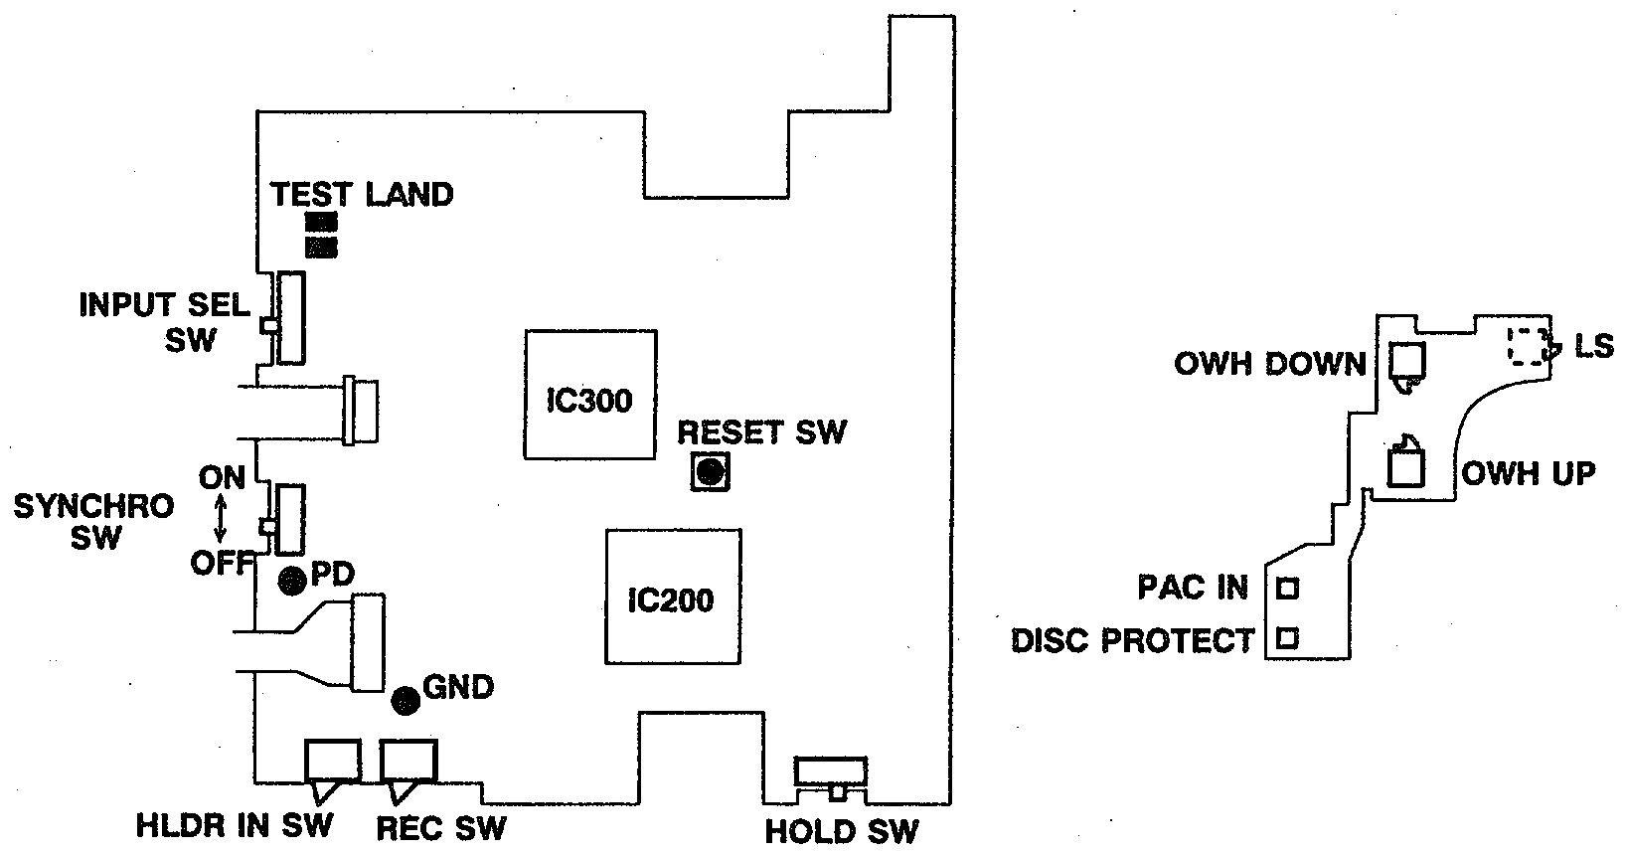

Test Mode
Note When Handling Discs
In Test and Adjustment Modes, "HOLD" switch of the main unit distinguishes discs.
When insert a disc, check the "HOLD" switch.
PIT disc (e.g. TEST DISC TGYS-1) : Turn on "HOLD" switch of the main unit.
MO disc (fully recorded MDW-74) : Turn off "HOLD' switch of the main unit.

1. Start and Cancel Test Mode
1) Starling Test Mode
There are 2 ways to start Test Mode.
a. Press "REC/EDIT" key and "B-SKIP" key together, and then press "RESET" (to startTest Mode without removing the exterior.).
b. Switch off "SYNCHRO" and short the testland of the main circuit board. Then press "RESET". Once Test Mode is started, all LCDs will be turned on to display [Welcome To Mini Disk World].

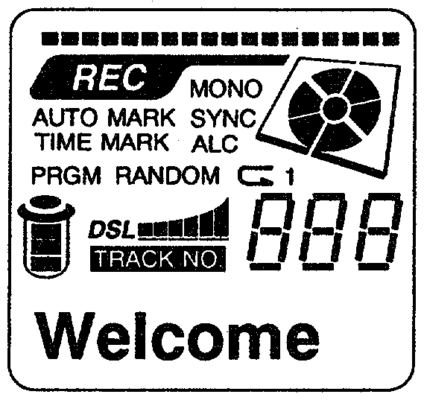  LCD Display of the main unit | 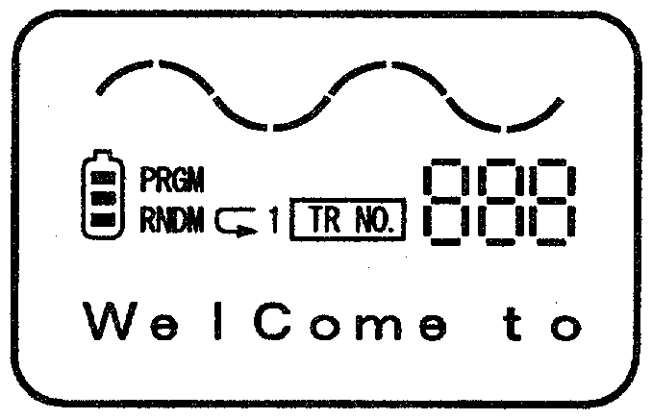  LCD Display of remote controller

2) Canceling Test Mode
a. Press reset switch.
b. Plug off AC plug and turn off the power.

Caution
* Ignore mechanism failure during Test Mode operation. If any operation failures were detected, plug off the power supply.
* No replay or record while Test Mode is on.
* Do not insert a disc when OWH (Over Write Head) is lowered.
2. Remote controller LCD Display
Once Test Mode is started, all LCD of both main unit and remote controller will be turned on.

3. Audio Output Check
It checks playback audio circuit (DAC, HP AMP).
After Test Mode was started, l KHz, -32.4dbv (24mV) signal is output from PHONE OUT when all LCD displays turned on.

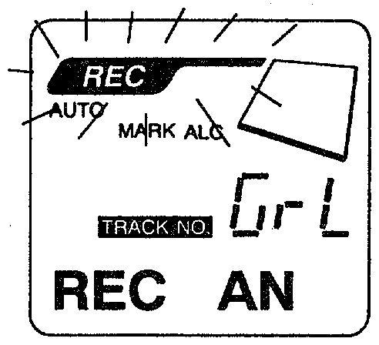
4. REC Monitor Check
Press "STOP" key to turn off LCD display and turn on [SV OFF] display.
lt checks REC audio circuit (MIC/LINE AMP, ADC). Input digital/analog source signals when [SV OFF] display is on, and press "REC" key to check the monitor sound. Then LCD displays "REC" to indicate that the signals are inputted.

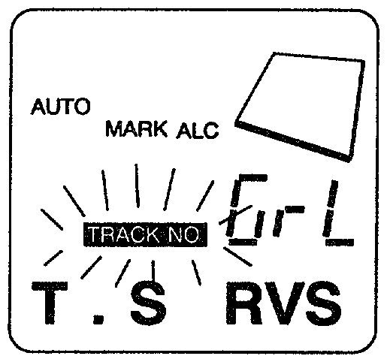
5. Sledding Operation Check
lt checks the Pick-Up sledding operation when [SV OFF] display is on.
When the Pick-Up is at the most internal circumference, LCD of the main unit displays [TRACK NO].
* Press "F-SKIP" key to shift the Pick-Up to the external circumference. Display [T.S FWD]
* Press "B-SKIP" key to shift the Pick-Up to the internal circumference . Display [T.S RVS]

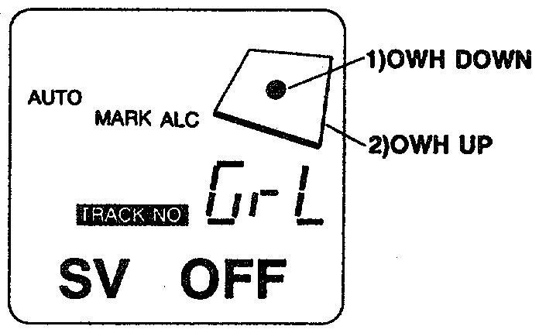
6. OWH (Over Write Head) Operation Check
lt checks the up-down movement of OWH when [SV OFF] display is on.

1) DOWN DETECT
Press "ENTER" key to lower down OWH and display DISC center.
2) UP DETECT
Press "SEARCH" key to raise up OWH and display DISC outline.

Caution
* Do not lower down OWH when insert a high-reflection disc.
* If insert a disc with OWH lowered, it may result in bending OWH.

7. Various Switch Operation Check
ON/OFF condition (condition of switch contact) of various switches of the main unit and the mechanism can be checked on the LCD Display on the main unit.
Press "STOP" key to turn off LCD displays and turn on [SV OFF] display.

* Main unit LCD Display
1) HOLDER IN
Display [MARK] of TIME MARK, once the top panel is closed (switch on "HLDR IN").

2) HOLD
Display Battery outline, once the "HOLD" switch on the main unit is turned on.

3) SYNCHRO
Display [SYNC], once "SYNCHRO" switch is turned on.

4) INPUT SELECT
LCD display of the main unit will be switched over depending on the position of "INPUT SELECT" switch.
* MIC HIGH -> Display [TIME].
* MIC LOW -> Display [MARK] of AUTO MARK.
* LINE -> Display [AUTO].
5) INPUT (OPT/LINE/MIC)
When Optical Plug is inserted, [ALC] display will turn off.

6) PACK IN
When the disc is inserted, disc falls will turn on.

7) DISC PROTECT
When a recordable MO disc (the write-protect tab is blocked) is inserted, it displays REPEAT.

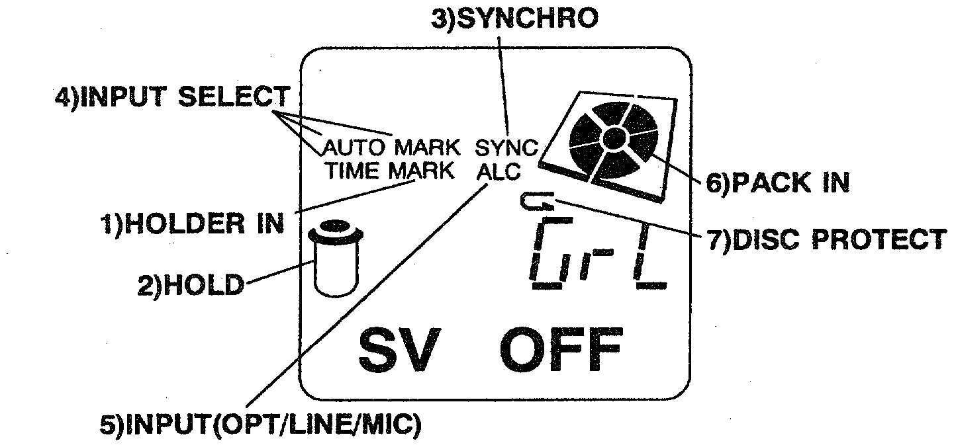

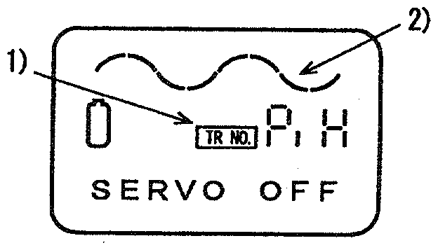
* Remote controller LCD Display
1) Displays [TRNO.] when HOLD switch on the main unit is on. However, not when HOLD switch on the remote controller is on.
2) Displays [- -] when the top panel is closed (turn on "HLDR IN" switch).

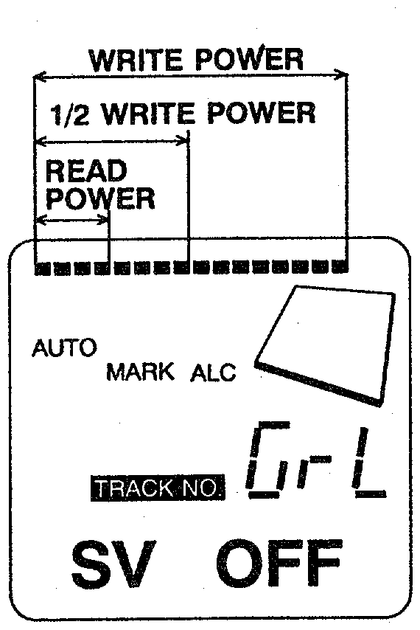
8. Laser Output Check
Press "DSL" key when [SV OFF] display is on, to make the Pick-Up lasers radiate. The level of luminosity will change every time "DSL" key is pressed. The level meter of LCD displays the lasers' luminosity level.
OFF → READ POWER → 1/2 WRITE POWER → WRITE POWER
↑_______________________________________________|

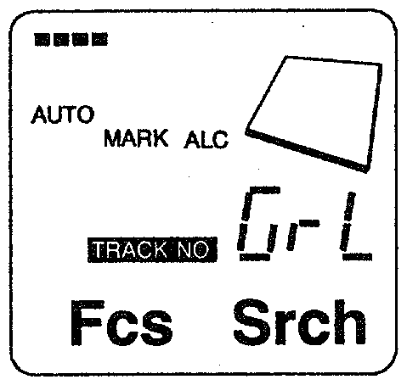
9. Servo Operation Check
1) Focus Search and Spindle Kick
Press "PLAY" key without no disc inside, to visually check the Focus Search and spindle Kick. lt displays [Fes Srch].

* PIT disc (TEST DISC TGYS-1) : Turn on "HOLD" on the main unit.
* MO disc (MDW-74) : Turn off "HOLD" on the main unit.

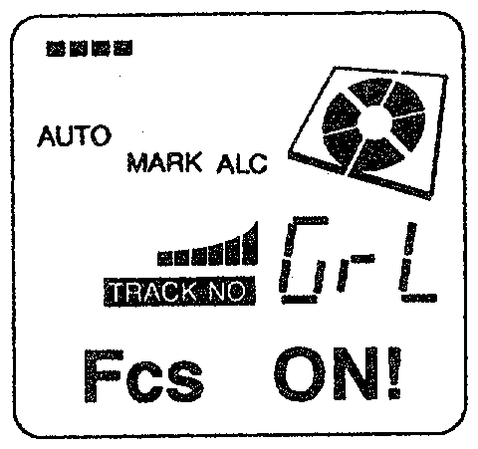
2) Focus Servo On
Insert a disc and press "PLAY" key to set focus and display [Focus ON!]. Insert a MO disc and press "ENTER" key to lower OWH down. If "PLAY" key is pressed in this condition, it will not set focus.

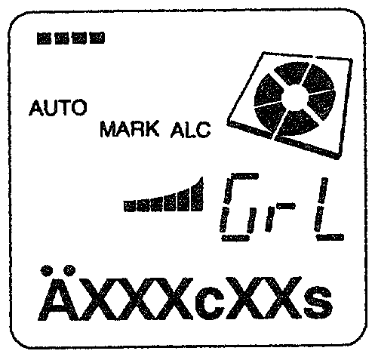
3) All Servo On
Press "MODE" key with focus servo on to turn on tracking and sledding servo, and lock spindle servo. Then, LCD on the remote controller will display disc addresses .
XXXc : cluster
XXs : sector

4) Switching between CAV/CLV of Spindle Servo
Spindle servo is operated by CAV servo when all servos are on. Press "MULTI JOG" key to switch from CAV servo to CLV servo.
However, it cannot be switched back from CLV servo to CAV when all servos are on.
In order to start CAV servo, press "STOP" key to terminate the operation and turn all servos back on.

5) Track Jump
Press "MULTI JOG" key after setting all servo on, to jump tracks.
* "+" direction to jump tracks in FWD
* "-" direction to jump tracks in RVS

10. Adjustment Values and Error Rate Check
Press "DISP" key in each operation to display the following values on LCD.

1) Adjustment Value Check
Press "DISP" key when [SV OFF] display is on, to check temperature preset value, IVR value, EF Balance value, Focus Gain, Tracking / Sledding Gain.

SV OFF ←┐ Press the [DISP] key to switch adjustment values.
↓ |
TEMP * * C | a) Temperature (the internal temperature of the main unit is displayed.)
↓ |
iv * * ef * * | b) IVR and EF balance values
↓ |
Gf * * ts * * ─┘ c) Focus Gain and Tracking/Sled Gain value

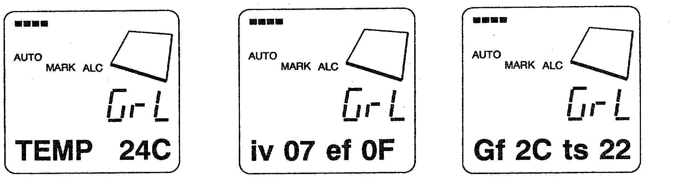

* Default Value
a) Temperature Display
Same as the room temperature (immediately after turning on the power)
PIT disc adjustment value
Turn on "HOLD" switch, display [Pi H].
iv : 14 ~ 19 ef : 09 ~ 15
Gf : 40 ~ 80 ts : 15 ~ 40

MO disc adjustment value
Turn off "HOLD" switch, display [Gr L].
iv : 05 ~ OA ef : 09 ~ 15
Gf : 30 ~ 70 ts : 15 ~ 40

2) EF Balance Value Check
Insert a disc and press "DISP" key with [Focus ON!] display on, to check EF Balance DC Offset value.

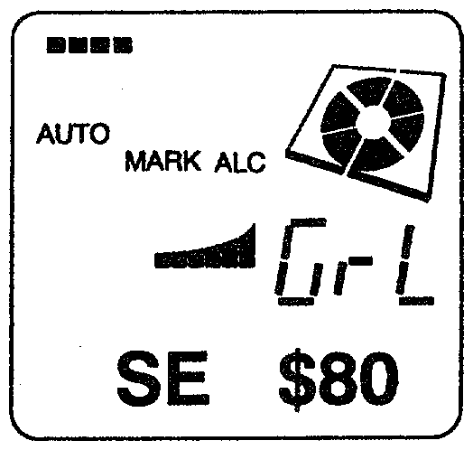
Focus ON! ←┐
↓ |
SE $ * * ─┘ SLED ERROR
(EF balance)
centre value
SE $ 8 0

3) Error Rate Check
Press "DISP" key with All Servo On, to display Error Rate.
lt displays the error rate of recorded discs, which can be used to check the recording condition of discs.

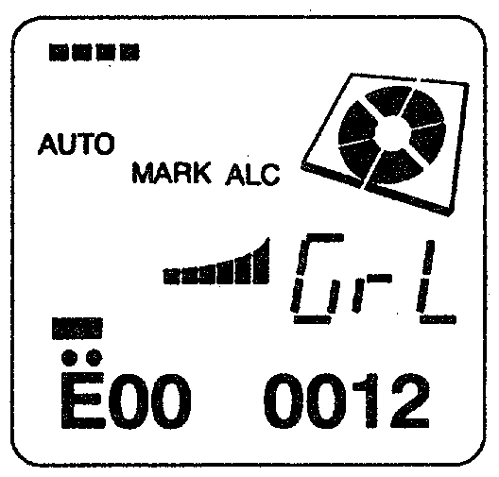
* * * c * * s ←┐ Address
↓ |
Er * * ΔΔΔΔ ─┘ Error rate
* * : C2 Error
ΔΔΔΔ : Cl Error

a) PIT disc (TGYS-1)
1. Turn on "KEY HOLD" switch and display [PiH].
2. Shift Pick-Up to the slightly more external position than the most inner circumference.
3. Press "PLAY" key and then "MODE" key to set all servo on and adjust address at approximately 600s00.
4. Press "DISP" key to check that Cl error is below [0030].

b) MO disc (MDW-74)
1. Turn off "KEY HOLD" switch to display [GrL].
2. Set all servo on and adjust address at approximately 600s00.
3. Check that Cl error is below [0030].

c) Record/Playback Error Rate
1. Turn off "KEY HOLD" switch to display [GrL].
2. Insert a MO disc and press "F-SKIP" key to shift the Pick-Up to the slightly more external position than the most inner circumference.
3. Press "ENTER" key to lower down OWH.
4. Press "REC/EDIT" key to display [REC AN].
5. Press "PLAY" key to display [Fes ON!].
6. Press "MODE" -> "REC" keys to check that recording starts at 600c.
7. Record for 15 seconds and press "STOP".
8. Press "SEARCH" key to raise up OWH.
9. Press "PLAY" -> "MODE" keys to check that the address is set at approximately 600s00.
10. Press "DISP" key to check that Cl error is below [0030].

ADJUSTMENT MODE
Einstellungs-Modus

1. Start and Cancel Adjustment Mode
1. Start und Cancel Einstellungs-Modus

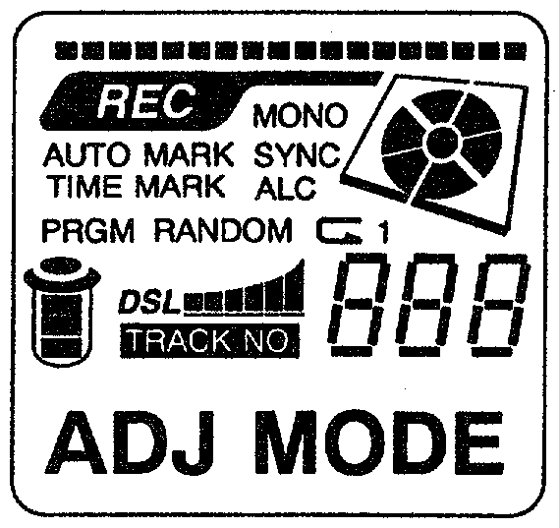
1) Starting Adjustment Mode
1) Start-Einstellungs-Modus

Turn on "SYNCHRO" switch and short the testland of the main circuit board. Then press "RESET". Once Adjustment Mode is started, LCD will be all turned on to display [ADJ MODE].
Schalte den "SYNCHRO"-Schalter ein und schließe den Test-Punkt auf der Hauptplatine kurz {vermutlich auf GND}. Dann drücke auf "RESET". Wenn der Einstellungs-Modus gestartet hat, leuchten auf dem LCD alle Segmente aktiviert. (Wir sind jetzt im} Einstellungs-Modus.

2) Canceling Adjustment Mode
2. Beenden des Einstellungs-Modus
* Press "RESET" switch.
* drücke den "Reset"-Schalter.
* Plug off AC plug and turn off the power.
* Den Netzstecker ziehen und das Gerät ausschalten.

* If adjustment is not complete, it displays [NO ADJ!].
* Wenn der Einstellungs-Modus nicht vollständig ist, wird [NO ADJ!] [keine Einstellung vorgenommen] angezeigt.

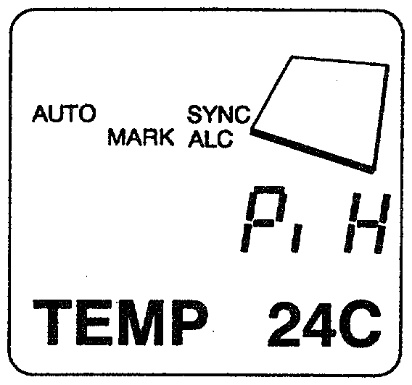
2. Temperature Compensation
2. Temperaturkompensation {Abgleich des Temperatursensors}
Press "STOP" key to display [SV OFF].
Drücke die "STOP"-Taste, [SV OFF] wird angezeigt
Press "DISP" once to display [TEMP **C].
Drücke die "DISP"-Taste einmal, [TEMP **C] wird angezeigt.
Use "ENTER" "SEARCH" keys to adjust the displayed temperature value to the room temperature.
Verwende die "ENTER"- und "SEARCH"-Tasten, um die angezeigte Temperatur auf die echte Raumtemperatur einzustellen.

Note
Beachte
Make this adjustment immediately after turning on the power.
Diese Einstellung gleich nach dem Einschalten des Gerätes machen {damit der Temperatursensor noch Raumtemperatur hat und das Gerät sich noch nicht erwärmt hat}.
Make sure that the temperature of the circuit board is same as the room temperature.
Die Temperatur der Hauptplatine {, auf der sich der Sensor befindet,} soll gleich sein wie die Raumtemperatur.

3. Laser Power
3. Leistung des Lasers
lt adjusts the laser power of Read/Write.
Damit wird die Laserleistung des Schreib-Leselasers eingestellt.
Press "STOP" key to display [SV OFF].
Drücke die "STOP"-Taste, [SV OFF] wird angezeigt.

Caution
Beachte:
* Do not make this adjustment with a disc inside, as it may damage the disc.
* Für diese Einstellung darf sich keine Disk im Gerät befinden, da sie zerstört würde.

Procedure
Vorgehensweise:
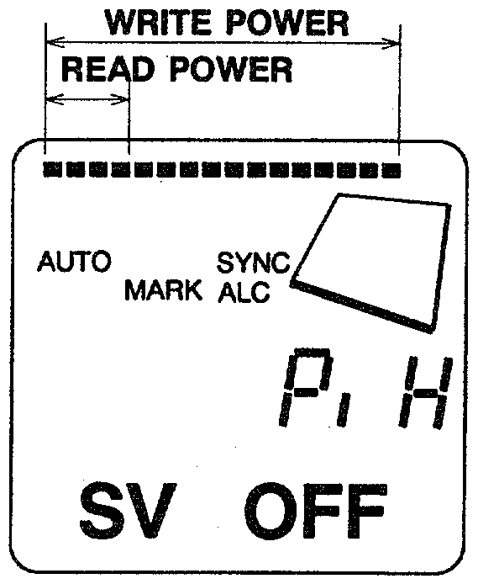
* READ POWER ADJUSTMENT
* Einstellen der Lese-Leistung
Press "DSL" key once to increase one grade of a level meter. Check the voltage between Test Points PD-GND with a digital multi meter. Use "ENTER" "SEARCH" to set digital multi meter display at 105±6mV.
Drücke die "DSL"-Taste einmal, um die Leistung um eine Stufe zu erhöhen. Prüfe die Spannung zwischen den Testpunkten PD und GND mit einem Digital-Multimeter. Drücke die "ENTER"- und die "SEARCH"-Taste, um die Spannung auf 105 +-6 mV einzustellen.

* WRITE POWER ADJUSTMENT
* Einstellen der Schreibleistung
Press "DSL" key twice to increase the grade of the level meter to the maximum. Check the voltage between Test Points PD-GND with a digital multi meter. Use "ENTER" "SEARCH" to set digital multi meter display at 810±6mV.
Drücke die "DSL"-Taste zweimal, um die Pegelanzeige auf das Maximum zu erhöhen. Messe die Spannung zwischen den Testpunkten PD und GND mit einem Digital-Multimeter. Drücke die "ENTER"- und die "SEARCH"-Taste, um die Spannung auf 810±6 mV einzustellen.
4. Automatic Adjustment Mode
4. Automatischer Einstellungs-Modus
This mode automatically adjusts servos and maintains the adjustment data in EEPROM.
Dieser Modus stellt Servos automatisch ein und erhält die Einstellungs-Daten im EEPROM-Speicher.
Recommended making a new adjustment after every replacement of Pick-Up, microcomputer or EEPROM, and mechanism repair.
Es wird empfohlen, eine neue Einstellung nach jedem Austausch des Abnehmers, des Microcomputers oder des EEPROMS oder nach einer mechanischen Reparatur auszuführen.

Caution
Beachte
* If a disc had any stains or scars on, the adjustment may not be completed. Use a new clean disc for adjustment.
* Wenn eine Disk Flecken oder Kratzer hat, kann es sein, dass die Einstellung nicht vollständig ausgeführt wird.
* Always place the machine with its cassette cover upward for adjustment.
* Das Gerät immer so plazieren, dass der cassetten-Deckel für die Einstellung nach oben zeigt.
* Adjustment must be done on both PIT disc and MO disc. Otherwise it displays [NO ADJUST! ] and stops operating.
* Die Einstellung muss für beide Disketten-Systeme (PIT und MO) gemacht werden. Anderenfalls wird [NO ADJUST!] angezeigt und das Gerät stoppt.

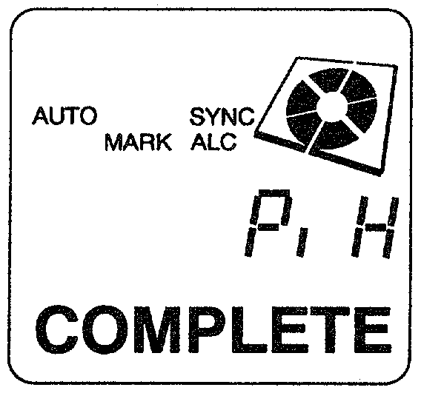
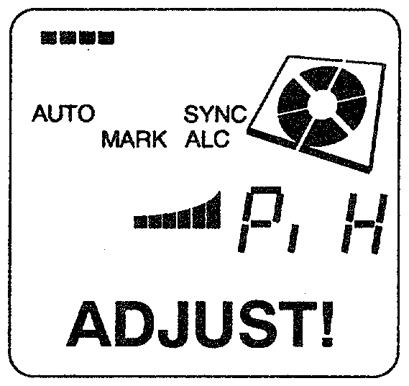
* PIT disc (test disc TGYS-1)
* PIT-Disk (Testdiskette TGYS-1)
* MO disc (fully recorded MDW-74 or equivalent)
* MO disk (voll aufgenommene MDW-74 oder gleichwertige)

Procedure
Vorgehensweise:
1. Insert a PIT disc and press "PLAY" key.
1. eine PIT-Diskette einlegen und "PLAY" drücken.
2. LCD displays [ADJUST!] and starts automatic adjustment.
2. [ADJUST!] wird am LCD angezeigt, eine automatische Einstellung wird gestartet.
3. Once the LCD display says [COMPLETE], the adjustment is done.
3. Sobald [COMPLETE] angezeigt wird, ist die Einstellung fertig.
4. Press "B-SKIP" key and get [TRACK NO.] on LCD display.
4. Drücke die "B-SKIP"-Taste, [TRACK NO.] wird angezeigt.
5. Insert a MO disc and press "PLAY".
5. eine MO-Diskette einlegen und "PLAY" drücken.
6. LCD displays [ADJUST!] and starts automatic adjustment.
6. [ADJUST] wird am LCD angezeigt, eine automatische Einstellung wird gestartet.
7. Once the LCD display says [COMPLETE], the adjustment is done.
7. Sobald [COMPLETE] angezeigt wird, ist die Einstellung fertig.

* If LCD displays [SERVO OFF], the adjustment is incomplete.
* Wenn [SERVO OFF] angezeigt wird, ist die Einstellung nicht abgeschlossen.

