RIGOL DSA815-TG - 2014-09-12

Content

Hidden Modes - Key and ScanCode

SCPI commands

SCPI commands list

SCPI parameter list

Non-visible menu items

SDRAM

Hidden Modes - Graphic

Correction file
Hidden Modes - Keys and ScanCode

Factory Boot Mode
BW 52 00 00 00
SWEEP 62 00 00 00
MARK 12 01 00 00
TG e2 00 00 00
MEAS f2 00 00 00
MEASSET 02 01 00 00
DEMOD c2 00 00 00

Requires an inserted USB flash drive.
Probably requires an appropriate firmware on the USB stick.

Maintenance Mode
TRACE d2 00 00 00
TG e2 00 00 00
MARKFUNC 22 01 00 00
MEASSET 02 01 00 00
SYSTEM 82 01 00 00
PRINTSETUP c2 01 00 00
STORAGE 92 01 00 00

Adds menu: System -> Service - Do not use Calibration -> Clr Int Cal
Adds function: TG -> ALC

Unknown Mode 1
BW 52 00 00 00
MARK 12 01 00 00
TRACE d2 00 00 00
TG e2 00 00 00
MARKFUNC 22 01 00 00
SWEEP 62 00 00 00
TG e2 00 00 00

Unknown Mode 2
MEASSET 02 01 00 00
PRINTSETUP c2 01 00 00
TG e2 00 00 00
MEAS f2 00 00 00
SYSTEM 82 01 00 00
TG e2 00 00 00
DEMOD c2 00 00 00

If the keys for „Unknown Mode 1“, „Unknown Mode 2“ and STORAGE is entered in the menu System -> Self-Test -> Key Test, a chinese text is displayed:

DSA系列产品声明
本产品版权为普源精电科技有限公司所有，盗版必究!

Google translation:
DSA Series Product Declaration
This product is copyright Rigol Technologies Ltd. All pirated reserved!

User Mode
STORAGE 92 01 00 00
ENTER e2 05 00 00
ESC d2 05 00 00
BACK c2 05 00 00
FREQ 12 00 00 00
FREQ 12 00 00 00
FREQ 12 00 00 00

Exits the Maintenance Mode.
SCPI commands

Firmware v01.09

:PRIVate:FACTory:SN? -> "DSA8A145208137"
:PRIVate:FACTory:MODEL? -> "DSA815"
:PRIVate:FACTory:MAC? -> "00-19-AF-52-06-F0"
:PRIVate:FACTory:RTC? -> "2014-07-20 16:19:14"
:PRIVate:FACTory:CALRtc? -> "2012-08-14 06-48-56"
:PRIVate:FACTory:AKEY? x -> "0"
:PRIVate:FACTory:SKEY? -> Output only if set. Do not use, all options will be lost.

:PRIVate:CTRL:DATAtype? -> "0"
:PRIVate:CTRL:ESR? -> "1"
:PRIVate:CTRL:SYNC? -> (:SYST:ERR? -220, "Parameter error")
:PRIVate:CTRL:TRACe? -> 9026 Bytes Testtrace

:PRIVate:TEMPeratue:GET? -> "0.000000E+00"

:PRIV:SOFT:VER? x -> "00.01.09"

Menu System -> Service -> Calibration:
:PRIVate:CALibration:AMPLref? -> "1167"
:PRIVate:CALibration:FREQref? -> "1799"
:PRIVate:CALibration:LOdac? -> "0"
:PRIVate:CALibration:CLKdac? -> "0"
:PRIVate:CALibration:ONdac? -> "0"
:PRIVate:CALibration:OFFdac? -> "0"

Menu System -> Service -> Log Manage:
:SERVice:LOG:DEVIce? -> "PC", "UDISK", "RMT" (Output Device: PC, U-Disk, Rmt-Monitor)
:SERVice:LOG:CPState? -> "0"

:SELFtest:KEY -> Brings up the Local 'Self Test' Menu for Key Test.
:SELFtest:SYS -> No response, no error

:DBGCMD:STAT? TX -> "(u16HostFetchErr = 0),(u16FifoLenErr = 0),(u32NoDataCnt = 0),(u32WaitDataCnt = 0),(u16FmtDataErr = 0),(u16FmtTypeErr = 0),(u16StateMachineErr = 0),(u16DeadLockCnt = 0),(u16SysFmtErr = 0),(u16AddrAccessErr = 0),(u32TotalTxByte = 56),(u32CurTxByte = 56)"

:DBGCMD:STAT? RX -> "(u16InteruptCnt = 0),(u16WInQCnt = 0),(u16RxDataCnt = 0),(u16ProCnt = 3),(u16IBFullCnt = 0),"

:DBGCMD:STAT? Q -> "(u16NoFreeNode = 0),(u16QIsFull = 0),(u16QIsEmpty = 0),(u16RxBufOverflow = 0),(u16RxDataPtrNull = 0),(u16RxDataLenErr = 0),"

:DBGCMD:STAT? PARSE -> "(u16InvalidCharacter = 0),(u16KeywordNotFound = 2),(u16CmdNotFound = 0),(u16TooManyKeyword = 0),(u16LastKeywordOmitted = 0),(u16CmdSNErr = 0),(u16InvalidCallBackFunc = 0),(u16CmdExcuteErr = 0),"

:DBGCMD:STAT? CLR -> "Clear all dbg stat."
:DBGCMD:VER? -> "SCP Module Ver : 00.02.02.00"

:KEYBoard:KEYValue Keyname

Keyname:

AMP
BACK
BW
DEMOD
DIGIT0
DIGIT1
DIGIT2
DIGIT3
DIGIT4
DIGIT5
DIGIT6
DIGIT7
DIGIT8
DIGIT9
DOT
DOWN
ENTER
ESC
F1
F2
F3
F4
F5
F6
F7
FREQ
HELP
KNOBL
KNOBR
MARK
MARKFUNC
MARKTO
MEAS
MEASSET
PAGEDOWN
PEAK
PRESET
PRINT
PRINTSETUP
RETURN
SPAN
STORAGE
SWEEP
SYSTEM
TG
TRACE
TUNE
UP

For example, show the frequency menu:
:KEYBoard:KEYValue ESC;:KEYBoard:KEYValue FREQ

or enter Maintenance Mode:
:KEYB:KEYV ESC;:KEYB:KEYV TRACE;:KEYB:KEYV TG;:KEYB:KEYV MARKFUNC;:KEYB:KEYV MEASSET;:KEYB:KEYV SYSTEM;:KEYB:KEYV PRINTSETUP;:KEYB:KEYV STORAGE

:SYST:FREad? Address decimal, length decimal -> Read Flash memory
The DSA uses only 4 MB of the 8 MB.

Read the first 4 MB.:
:SYST:FRE? 0,1048576
:SYST:FRE? 1048576,1048576
:SYST:FRE? 2097152,1048576
:SYST:FRE? 3145728,1048576

Read the next 4 MB, the same data is read again:
:SYST:FRE? 4194304,1048576
:SYST:FRE? 5242880,1048576
:SYST:FRE? 6291456,1048576
:SYST:FRE? 7340032,1048576

:SYST:FWRite Address decimal, length decimal, data -> Write Flash memory
Only text data is written properly, eg. :SYST:FWR 4194048,8,ABCD1234
A byte with the value zero can be written only with tricks.

SCPI commands

TEST:ONE15
TEST:ONE16
TEST:ONE17
TEST:ONE18
TEST:ONE19
TEST:ONE20
TEST:ONE21
TEST:ONE22
TEST:ONE23
TEST:ONE24
TEST:ONE25
TEST:ONE26
TEST:ONE27
TEST:ONE28
TEST:ONE29
TEST:ONE30
TEST:ONE31
TEST:ONE32
TEST:ONE33
TEST:ONE34
TEST:ONE35
TEST:ONE36
TEST:ONE37
TEST:ONE38
TEST:ONE39
TEST:ONE40
TEST:ONE41
TEST:ONE42
TEST:ONE43
*CLS
*ESE *ESE?
*ESR?
*IDN?
*OPC *OPC?
*RST
*SRE *SRE?
*STB?
*TRG
*TST?
*WAI
ABORt ABOR
CALCulate CALC
BANDwidth BAND
NDB NDB?
RESult? RES?
MARKer MARK
AOFF
CPEak CPE
STATe STAT STATe? STAT?
DELTa DELT
SET
CENTer CENT
SPAN
FCOunt FCO
RESolution RES RESolution?
AUTO AUTO?
X?
FUNCtion FUNC FUNCtion? FUNC?
MAXimum MAX
LEFT
NEXT
RIGHt RIGH
MINimum MIN
MODE MODE?
PEAK
EXCursion EXC EXCursion? EXC?
SEARch SEAR
CF
THReshold THR THReshold? THR?
PTPeak PTP
RLEVel RLEV
STARt STAR
STEP
STOP
TABLe TABL
TRACe TRAC TRACe? TRAC?
TRCKing TRCK TRACking
X
CENTer? CENT?
POSition POS POSition? POS?
SPAN?
STARt? STAR?
STOP?
READout READ READout? READ?
Y?
VSRefl? VSR?
VSValue? VSV?
LLINe LLIN
ALL
DELete DEL
CONTrol CONT
DOMain DOM DOMain? DOM?
INTerpolate INT
TYPE TYPE?
DATA DATA?
MERGe MERG
FAIL FAIL?
RATIo? RATI?
RELFreq RELF RELFreq? RELF?
RELAmpt RELA RELAmpt? RELA?
NTData NTD
CALibration CAL
ACCUrate ACCU
SIGNal SIGN SIGNal? SIGN?
CONFigure CONF
ACPower ACP
CHPower CHP
CNRatio CNR
EBWidth EBW
HDISt HDIS
OBWidth OBW
SANalyzer SAN
TOI
TPOWer TPOW
PF
CONFigure? CONF?
COUPle COUP COUPle? COUP?
DISPlay DISP
AFUnction AFU
ANNotation ANN
CLOCk CLOC
BRIGtness BRIG BRIGtness? BRIG?
BRIGHtness BRIGH BRIGHtness? BRIGH?
FSCReen FSCR
ZSCReen ZSCR
SSCRenn SSCR
ENABle ENAB ENABle? ENAB?
MSGswitch MSG
WINdow WIN
GRATicule GRAT
GRID GRID?
Y
DLINe DLIN DLINe? DLIN?
SCALe SCAL
PDIVision PDIV PDIVision? PDIV?
RLEVel? RLEV?
OFFSet OFFS OFFSet? OFFS?
SPACing SPAC SPACing? SPAC?
NRLevel NRL NRLevel? NRL?
NRPosition NRP NRPosition? NRP?
UKEY
FETCh FETC
ACPower? ACP?
LOWer? LOW?
UPPer? UPP?
MAIN?
CHPower? CHP?
DENSity? DENS?
CNRatio? CNR?
CARRier? CARR?
NOISe? NOIS?
EBWidth? EBW?
HARMonics HARM
AMPLitude AMPL AMPLitude? AMPL?
ALL?
DISTortion? DIST?
FREQuency FREQ FREQuency? FREQ?
FUNDamental? FUND?
OBWidth? OBW?
FERRor? FERR?
TOIntercept TOIntercept? TOI?
IP3?
TPOWer? TPOW?
FORMat FORM
BORDer BORD BORDer? BORD?
HCOPy HCOP
IMAGe IMAG
COLor COL
INVert INV INVert? INV?
PTIMe PTIM PTIMe? PTIM?
QUALity QUAL QUALity? QUAL?
FTYPe FTYP FTYPe? FTYP?
IMMediate IMM
PAGE
ORIentation ORI ORIentation? ORI?
PRINts PRIN PRINts? PRIN?
SIZE SIZE?
RESume
INITiate INIT
CONTinuous CONTinuous? CONT?
PAUSe PAUS
RESTart REST
INPut INP
IMPedance IMP IMPedance? IMP?
MMEMory MMEM
MOVE
LOAD
CORRection CORR
SETUp SETU
LIMit LIM
MTABle MTAB
STORe STOR
SCReen SCR
RESults
PTABle PTAB
DISK
INFomation? INF? INFOrmation? INFO?
OUTPut OUTP
SENSe SENS
VIDeo VID VIDeo? VID?
RATio RAT RATio? RAT?
EMIFilter EMIF
CSET
DEMod DEM DEMod? DEM?
TIME TIME?
DETector DET
INCRement INCR INCRement? INCR?
UP
DOWN
FULL
PREVious PREV
ZIN
ZOUT
ZONE
RZONe RZON
LZONe LZON
SYSNThesis SYSNT SYSNThesis? SYSNT?
POWer POW
RF
ATTenuation ATT ATTenuation? ATT?
GAIN
MIXer MIX
RANGe RANG
UPPer UPP
ASCale ASC
ARANge ARAN
ATUNe ATUN
SWEep SWE
COUNt COUN COUNt? COUN?
CURRent? CURR?
RULes RUL RULes? RUL?
AVERage AVER
TCONtrol TCON TCONtrol? TCON?
INTegration INTegration? INT?
ACHannel ACH ACHannel? ACH?
CSPacing CSP CSPacing? CSP?
NOISe NOIS
MAXHold MAXH
XDB XDB?
NUMBers NUMB NUMBers? NUMB?
PERCent PERC PERCent? PERC?
LLIMit LLIM LLIMit? LLIM?
RLIMit RLIM RLIMit? RLIM?
VSWR
RESet
FREFlect FREF
NREFlect NREF
SOURce SOUR
LEVel LEV
SWEep? SWE?
STORref
REF
ALC
STATus
OPERation OPER
CONDition? COND?
EVENt? EVEN?
PRESet PRES
QUEStionable QUES
SYSTem SYST
COMMunicate COMM
APORt APOR APORt? APOR?
GPIB
SELF
ADDRess ADDR ADDRess? ADDR?
LAN
DHCP
AUToip AUT
MANuip MAN
IP
ADDress ADD ADDress? ADD?
SUBMask SUBM SUBMask? SUBM?
GATeway GAT GATeway? GAT?
DNSServer DNSS DNSServer? DNSS?
DNAMe DNAM DNAMe? DNAM?
HNAMe HNAM HNAMe? HNAM?
PASSword PASS PASSword? PASS?
SERial SER
RECeive REC
BAUD BAUD?
PARity PAR PARity? PAR?
USB
CLASs CLAS CLASs? CLAS?
MESSage? MESS?
DATE DATE?
ERRor ERR
NEXT?
LANGuage LANG LANGuage? LANG?
LKEY LKEY?
OPTions? OPT?
PON
SAVE
SPEaker SPE
VOLume VOL VOLume? VOL?
BEEPer BEEP
LINemod LIN
TYPe TYP
USERkey USER
KEYCmd KEYC KEYCmd? KEYC?
CONFirm
VERSion? VERS?
FSWItch FSWI
TX
SWSTa? SWST?
SWSet SWS
FREad? FRE?
FWRite FWR
MATH
SUBTract SUBT
POINts? POIN?
SORT SORT?
A A?
B B?
CONSt CONS CONSt? CONS?
CLEar CLE
TRIGger TRIG
SEQuence SEQ
EXTernal EXT
SLOPe SLOP SLOPe? SLOP?
READy?
SOURce? SOUR?
LEVel? LEV?
TRIger TRI
UNIT
POWer? POW?
KEYBoard KEYB
KEYValue KEYV
SELFtest
KEY
SYS
SERVice SERV
LOG
DEVIce DEVI DEVIce? DEVI?
CPState CPS CPState? CPS?
PRIVate PRIV
AMPLref AMPLref?
FREQref FREQref?
LOdac LO LOdac? LO?
CLKDac CLKD CLKDac? CLKD?
ONDac OND ONDac? OND?
OFFDac OFFD OFFDac? OFFD?
WRITeflash WRIT
READflash?
WNVram WNV
RNVram? RNV?
TGCal TGC
TEMPeratue TEMP
GET?
COMPensate COMP
SNAPscr? SNAP?
TEST
FloodData FD FloodData? FD?
FACTory FACT
SN SN?
MODEL MODEL?
MAC MAC?
RTC RTC?
CALRtc CALR CALRtc? CALR?
AKEY AKEY?
SKEY SKEY?
SOFT
VER?
CTRL
DATAtype?
SYNC?
ESR?
CMD1
CMD2
CMD3
CMD4
CMD5
CMD6
CMD7
CMD8
CMD9
CMD10
CMD11
CMD12
CMD13
CMD14
CMD15
CMD16
CMD17
CMD18
CMD19
CMD20
CMD21
CMD22
CMD23
CMD24
CMD25
CMD26
CMD27
CMD28
CMD29
CMD30
CMD31
CMD32
CMD33
CMD34
CMD35
CMD36
CMD37
CMD38
CMD39

SCPI parameter

Rigol Technologies,%s,%s,%s
ERR
NULL
N/A
ALL
NONE
.cbl
.CBL
.CSV
CSV
TRC
TRACE1
TRACE2
TRACE3
MATH
MKR
OFF
ERR
.sta
BMP
JPEG
1LOCUR
1LOMUXOUT
1LOFREQ
1LOR0
1LOR1
1LOR2
1LOR3
1LOR4
1LORALL
1LOCH
1LOBW
2LOCUR
2LOMUXOUT
2LOFREQ
2LOR0
2LOR1
2LOR2
2LOR3
2LORALL
TGLOCUR
TGLOMUXOUT
TGLOFREQ
TGLOR0
TGLOR1
TGLOR2
TGLOR3
TGLOR4
TGLORALL
TGATT
DACA
DACB
LORATE
SPIPHASEEXE
SPIPHASEUP
SPIPHASESET
OFF
AM
FM
PM
POS
NEG
SAMP
NORA
RMS
VAV
ERR
NORM
ACC
EXP
REP
PEAK
AVER
QPEAK
SWE
FIX
IMM
EXT
VID
DBM
DBUV
DBMV
V
W
CLAS
MODE
DEF
DRAF
FINE
EXIF
PORT
LAND
A4
A5
A6
B5
FREQ
AMPL
DLM
DLL
WRIT
MAXH
MINH
POW
VIEW
BLANK
LOWERL
UPPERL
T1
T2
T3
T_MATH
A-B
A+CONST
A-CONST
NOIS
NDB
MAX
PAR
PER
TIME
ITIM
DELT
BAND
SPAN
TPOW
ACP
CHP
OBW
EBW
CNR
HD
TOI
PF
NULL
LOG
LIN
UNMEAS
PASS
FAIL
INT
LAN
USB
GPIB
115K
57.6K
38.4K
19.2K
9600
4800
2400
NONE
ODD
EVEN
ENGL
CHIN
JAPANESE
GERMAN
POLISH
PORTUGESE
KOREA
FACT
USER1
USER2
USER3
USER4
USER5
USER6
AUTO
TMC
PRIN
LAST
PRES
TOP
CENT
BOTT
SWAP
ASCII
REAL,32
PC
UDISK
RMT
USER
FACTORY
REPAIR
COLOR_EGG
ON
ANT
ANTENNA
CAB
CABLE
OTH
OTHER
EXPONENTIAL
REPEAT
NEGATIVE
NORMAL
POSITIVE
SAMPLE
VAVERAGE
QPE
ACCURACY
AVERAGE
FIXED
SWEEP
IMMEDIATE
EXTERNAL
VIDEO
CLASSIC
MODERN
DEFAULT
DRAFT
EXIFJPEG
LANDSCAPE
PORTRAIT
FREQUENCY
AMPLITUDE
DLMORE
DLLESS
WRITE
MAXHOLD
MINHOLD
VIDEOAVG
POWERAVG
BLAN
2
3
MATH
4
NOISE
POSITION
DELTA
MAXIMUM
PARAMETER
PERIOD
ITIME
LOGARITHMIC
LINEAR
INTERNAL
BOTTOM
CENTER
PRINTER
ENGLISH
CHINESE
JAPAN
JAP
GERM
POL
KOR
PRESET
ASC
REAL
SWAPPED
TRACE1
TRACE2
TRACE3
TRACE4
50
75
GHZ
MHZ
KHZ
HZ
PS
NS
US
MS
KS
S
SW1
SW2
SW3
SW4
SW5

Non-visible menu items. It is only the text available.

System -> Licence -> Install
Del Option
Storage
Cover file
Reenter

Menu text english:

Frequency.Center Freq.Start Freq.Stop Freq.CF Step.Auto.Manual.Signal Track.On.
Off.Peak->CF.CF->Step.Span.Span.Full Span.Zero Span.Zoom In.ZoomOut.Last Span.
Amplitude.Auto Scale.Ref Level.Input Att..Auto.Manual.Scale/Div.Scale Type.Log.
Lin.Units.dBm.dBmV.dBuV.Volts.Watts.Ref Offset.Auto Range.RF Preamp.On.Off.
Corrections.Select.Off.Antenna.Cable.Other.User.Correction.On.Off.Edit.Point.
Frequency.Amplitude.Del Point.Freq Interp.Log.Lin.Delete.OK.Cancel.Corr Table.
On.Off.Corr View.All .Sel.MaxMixL.Input.50¦¸.75¦¸.BW/Det.RBW.Auto.Manual.VBW.
Auto.Manual.V/R Ratio.Det Type.Pos Peak.Neg Peak.Sample.Normal.RMS Avg.
Voltage Avg.Quasi-Peak.Filter Type.Gauss.EMI.Sweep/Trig.Time.Auto.Manual.
Auto SWT.Normal.Accy.Mode.Single.Cont.Single.Numbers.Trig Type.FreeRun.Video.
External.Trig Setup.Video.Trig Level.External.Edge.Pos.Neg.Auto .Demod.Demod.
Off.AM.FM.Demod Setup.AM.Earphone.On.Off.Volume.Demod Time.FM.Earphone.On.Off.
Volume.Demod Time.Trace/PF.Select Trace.1.2.3.Trace Type.Clear Write.Max Hold.
Min Hold.Video Avg.Power Avg.Freeze.Blank.Avg Times.Trace Math.Function.A-B.
A+Const.A-Const.A.T1.T2.T3.B.T1.T2.T3.Const.Operate.On.Off.Clear All.Pass/Fail.
Switch.On.Off.Setup.Limit.Upper.Lower.Test.On.Off.Edit.Limit.Upper.Lower.Point.
X Axis.Amplitude.Connected.Yes.No.Del Point.OK.Cancel.X Axis.Freq.Time.
Freq Interp.Log.Lin.Rel Setting.Rel Freq.On.Off.Rel Ampt.On.Off.Fail Stop.On.
Off.Del Limit.OK.Cancel.Beeper.On.Off.Restart.Pause.Resume.Meas Mode.Single.
Cont.Single.AVG Reset.TG.TG.On.Off.TG Level.TG Lvl Offset.Power Sweep.On.Off.
Power Range.Normalize.Stor Ref.Normalize.On.Off.Norm Ref Lvl.Norm Ref Pos.
Ref Trace.View.Blank.ALC.Auto.On.Off.Measure.VSWR.On.Off.Meas Fctn.Off.T-Power.
ACP.Chan Pwr.OBW.EBW.C/N Ratio.Harmo Dist.TOI.Restart.Pause.Resume.Meas Mode.
Single.Cont.Single.Meas Setup.T-Power.Avg Num.On.Off.Avg Mode.Exp.Repeat.
TP Type.Peak.Average.RMS.Start Line.Stop Line.ACP.Avg Num.On.Off.Avg Mode.Exp.
Repeat.Main CH BW.Adj CH BW.CH Spacing.Chan Power.Avg Num.On.Off.Avg Mode.Exp.
Repeat.Integ BW.CH PwrSpan.OBW.Avg Num.On.Off.Avg Mode.Exp.Repeat.Max Hold.On.
Off.OBW Span.Power Ratio.EBW.Avg Num.On.Off.Avg Mode.Exp.Repeat.Max Hold.On.Off.
EBW Span.EBW X dB.C/N Ratio.Avg Num.On.Off.Avg Mode.Exp.Repeat.Offset Freq.
Noise BW.Carrier BW.Harmo Dist.Avg Num.On.Off.Avg Mode.Exp.Repeat.NO.of Harmo.
Harmonic ST.Auto.Manual.TOI.Avg Num.On.Off.Avg Mode.Exp.Repeat.TOI Span.VSWR.
Reset.Cal Open.VSWR.Marker.1.2.3.4.Marker State.On.Off.Ref Lvl.Marker.
Select Mkr.1.2.3.4.Normal.Delta.Delta Pair.Ref.Delta.Span Pair.Span.Center.Off.
Mkr Trace.1.2.3.Math.Auto.Readout.Frequency.Period.¦¤Time.1/¦¤time.Mkr Table.On.
Off.All Off.Marker Fctn.Select Mkr.1.2.3.4.Noise Mkr.N dB BW.Function Off.
Freq Count.State.On.Off.Resolution.Auto.Manual.Marker->.Mkr->CF.Mkr->Step.
Mkr->Start.Mkr->Stop.Mkr->Ref.Mkr¦¤->CF.Mkr¦¤->Span.Peak.Next Peak.Peak Right.
Peak Left.Min Search.Peak Peak.Cont Peak.On.Off.Search Para.Pk Excursn.
Pk Thresh.Peak Search.Max.param.Peak Table.State.On.Off.Peak Sort.Freq.Ampl.
Pk Readout.Normal.>DL.<DL.Preset.System.Language.English.ÖÐÎÄ.ÈÕ±¾ÕZ.Portugu¨ºs.
Deutsch.Polski.???.Reset.Power On.Last.Preset.Preset Type.Factory.User1.User2.
User3.User4.User5.User6.Save Preset.OK.Cancel.Calibrate.Cal Now.Self-Cal.On.Off.
Acc Cal.I/O Setting.Remote I/O.Off.LAN.USB.GPIB.LAN.Reset.OK.Cancel.Config.OK.
Cancel.DHCP.On.Off.Auto-IP.On.Off.Manual-IP.On.Off.IP.IP Address.Subnet Mask.
Gateway.DNS.USB.Dev Class.AutoConfig.TMC.Printer.Dev Addr.GPIB.Display.
DisplayLine.On.Off.Active Fctn.Top.Center.Bottom.Graticule.Scr State.On.Off.
Brightness.UserKey.On.Off.Msg Switch.On.Off.Work Setting.Front Switch.On.Off.
Line Mode.Factory.User1.User2.User3.User4.User5.User6.UserKey Set.On.Off.
Coupl Param.Information.System Info.System Msg.Self-Test.Screen Test.Key Test.
Time/Date.Time/Date.On.Off.Set Time.Set Date.License.Option Info.License Info.
Install.OK.Cancel.Del Option.TX1000.Sw1.On.Off.Sw2.On.Off.Sw3.On.Off.Sw4.On.Off.
Sw5.On.Off.Service.Calibration.Cal Switch.On.Off.Int Ref Signal.On.Off.
Clr Int Cal.Save Cal.Ref DAC.Cal DAC.LO DAC.TG Cal.On.Off.TG Att.Clk DAC.
Off DAC.On DAC.Log Manage.Log.On.Off.OutPut Dev.PC.U-Disk.Rmt-Monitor.CP state.
Signal Ctrl.Ph Noise Opt.On.Off.Storage.File Type.All.Setup.State.Trace.
Corrections.Limit.Measure.Mkr Table.Peak Table.Format.BIN.CSV.File Source.T1.
T2.T3.Trace Math.Trace All.Browser.Dir.File.Save.OK.Cover file.Reenter.Save.
Cancel.Cancel.Expand Dir.Collapse Dir.Recall.Rename.OK.Cancel.Delete.OK.Cancel.
Copy.Copy From.Copy To.Replace File.Cancel.Apply To.User1.User2.User3.User4.
User5.User6.Browser.Dir.File.Expand Dir.Collapse Dir.Create Dir.OK.Cancel.
Disk Info.Name Prefix.Prefix Switch.On.Off.Edit Prefix.OK.Cancel.Sys Update.
Print .Print Setup.Print.Resume.Cancel.Orientation.Portr.Landsc.Page Size.
Default.A4.A5.A6.B5.Inverted.On.Off.Palette.Gray.Color.Copies.Date Prints.On.
Off.Qualities.Default.Normal.Draft.Fine.FileType.Default.Exif/JPEG.BMP.Help.
User Key.Marker.Marker.Delta Marker.Marker Ref.Marker Delta.Marker Span.
Marker Center.Unit.U_Freq.GHz.MHz.kHz.Hz.U_Amp.U_dBm.dBm.-dBm.mV.uV.U_dBmV.dBmV.
-dBmV.mV.uV.U_dBuV.dBuV.-dBuV.mV.uV.U_Volts.V.mV.uV.nV.dBm.U_Watts.W.mW.uW.nW.
dBm.U_dB.dB.U_Time.ks.s.ms.us.ns.ps.U_Enter.Enter.U_Percent.%.LIST.L_T_POWER.
T-POWER.TP Type.L_ACP.Main CH Pwr.Upper.Lower.Adjacent Channel Power.L_CHP.
Channel Power.Power Spectral Density.L_OBW.Occupied BandWidth.
Transmit Freq Error.L_EBW.Emission BandWidth.L_CNR.Carrier Power.Noise Power.
CNRatior.L_HD.THD.Freq.Amp.Real Harmonics.Sweep Time.Harmonic Distortion.L_TOI.
dBc.Intercept.Base Lower.Base Upper.3rd Order Lower.3rd Order Upper.Pass.
P/F Ratio.L_MARKER.Marker.Trace.Type.X Axis.MarkerTable.Refl Coefficient.
Return Loss.L_PEAKER.Peak.L_CORR.Num.L_LAN.IP Setting.L_INFO_MSG.Msg ID.
Msg Content.Time.Line Mode: .Esc to exit..Invalid sweep Data.L_DISK_INFO.
Disk name.Type.Local disk.Mobile disk.File system.Used space.Free space.
Total space.Byte.Opt Install.Offical.Trial.Invalid.None.Forever

\SDRAM_FWv00.01.09.00.07_with-TG-TGCal-Options\dsa815_sdram.bin

........
........
........ SCPI parameter, commands
00470db0 52 69 67 6f 6c 20 54 65 63 68 6e 6f 6c 6f 67 69 Rigol Technologi
00470dc0 65 73 2c 25 73 2c 25 73 2c 25 73 00 24 21 0c 00 es,%s,%s,%s.$!..
........ .. .. .. .. .. .. .. .. .. .. .. .. .. .. .. .. ................
00470f50 31 4c 4f 43 55 52 00 00 31 4c 4f 4d 55 58 4f 55 1LOCUR..1LOMUXOU
00470f60 54 00 00 00 31 4c 4f 46 52 45 51 00 31 4c 4f 52 T...1LOFREQ.1LOR
........ .. .. .. .. .. .. .. .. .. .. .. .. .. .. .. .. ................
00471110 4f 46 46 00 41 4d 00 00 46 4d 00 00 50 4d 00 00 OFF.AM..FM..PM..
00471120 50 4f 53 00 4e 45 47 00 53 41 4d 50 00 00 00 00 POS.NEG.SAMP....
........ .. .. .. .. .. .. .. .. .. .. .. .. .. .. .. .. ................
00473240 35 00 00 00 43 4d 44 33 36 00 00 00 43 4d 44 33 5...CMD36...CMD3
00473250 37 00 00 00 43 4d 44 33 38 00 00 00 43 4d 44 33 7...CMD38...CMD3
00473260 39 00 00 00 9c 19 47 00 9c 19 47 00 ff ff 01 00 9...œ.G.œ.G.ÿÿ..
........
........
........ Menu text english
00603000 46 72 65 71 75 65 6e 63 79 00 43 65 6e 74 65 72 Frequency.Center
00603010 20 46 72 65 71 00 53 74 61 72 74 20 46 72 65 71 Freq.Start Freq
00603020 00 53 74 6f 70 20 46 72 65 71 00 43 46 20 53 74 .Stop Freq.CF St
00603030 65 70 00 41 75 74 6f 00 4d 61 6e 75 61 6c 00 53 ep.Auto.Manual.S
00603040 69 67 6e 61 6c 20 54 72 61 63 6b 00 4f 6e 00 4f ignal Track.On.O
00603050 66 66 00 50 65 61 6b 2d 3e 43 46 00 43 46 2d 3e ff.Peak->CF.CF->
00603060 53 74 65 70 00 53 70 61 6e 00 53 70 61 6e 00 46 Step.Span.Span.F
........ .. .. .. .. .. .. .. .. .. .. .. .. .. .. .. .. ................
........ .. .. .. .. .. .. .. .. .. .. .. .. .. .. .. .. ................
........ .. .. .. .. .. .. .. .. .. .. .. .. .. .. .. .. ................
........
........
........ Key ScanCode
01883780 1e 30 00 00 12 00 00 00 46 52 45 51 00 00 00 00 .0......FREQ....
01883790 00 00 00 00 22 00 00 00 53 50 41 4e 00 00 00 00 ...."...SPAN....
018837a0 00 00 00 00 32 00 00 00 41 4d 50 00 00 00 00 00 ....2...AMP.....
018837b0 00 00 00 00 52 00 00 00 42 57 00 00 00 00 00 00 ....R...BW......
018837c0 00 00 00 00 62 00 00 00 53 57 45 45 50 00 00 00 ....b...SWEEP...
018837d0 00 00 00 00 a2 00 00 00 54 55 4e 45 00 00 00 00 ....¢...TUNE....
018837e0 00 00 00 00 c2 00 00 00 44 45 4d 4f 44 00 00 00 ....Â...DEMOD...
018837f0 00 00 00 00 d2 00 00 00 54 52 41 43 45 00 00 00 ....Ò...TRACE...
01883800 00 00 00 00 e2 00 00 00 54 47 00 00 00 00 00 00 ....â...TG......
01883810 00 00 00 00 f2 00 00 00 4d 45 41 53 00 00 00 00 ....ò...MEAS....
01883820 00 00 00 00 02 01 00 00 4d 45 41 53 53 45 54 00 ........MEASSET.
01883830 00 00 00 00 12 01 00 00 4d 41 52 4b 00 00 00 00 ........MARK....
01883840 00 00 00 00 22 01 00 00 4d 41 52 4b 46 55 4e 43 ...."...MARKFUNC
01883850 00 00 00 00 32 01 00 00 4d 41 52 4b 54 4f 00 00 ....2...MARKTO..
01883860 00 00 00 00 42 01 00 00 50 45 41 4b 00 00 00 00 ....B...PEAK....
01883870 00 00 00 00 72 01 00 00 50 52 45 53 45 54 00 00 ....r...PRESET..
01883880 00 00 00 00 82 01 00 00 53 59 53 54 45 4d 00 00 ....‚...SYSTEM..
01883890 00 00 00 00 92 01 00 00 53 54 4f 52 41 47 45 00 ....’...STORAGE.
018838a0 00 00 00 00 b2 01 00 00 50 52 49 4e 54 00 00 00 ....²...PRINT...
018838b0 00 00 00 00 c2 01 00 00 50 52 49 4e 54 53 45 54 ....Â...PRINTSET
018838c0 55 50 00 00 d2 01 00 00 48 45 4c 50 00 00 00 00 UP..Ò...HELP....
018838d0 00 00 00 00 02 03 00 00 46 31 00 00 00 00 00 00 ........F1......
018838e0 00 00 00 00 12 03 00 00 46 32 00 00 00 00 00 00 ........F2......
018838f0 00 00 00 00 22 03 00 00 46 33 00 00 00 00 00 00 ...."...F3......
01883900 00 00 00 00 32 03 00 00 46 34 00 00 00 00 00 00 ....2...F4......
01883910 00 00 00 00 42 03 00 00 46 35 00 00 00 00 00 00 ....B...F5......
01883920 00 00 00 00 52 03 00 00 46 36 00 00 00 00 00 00 ....R...F6......
01883930 00 00 00 00 62 03 00 00 46 37 00 00 00 00 00 00 ....b...F7......
01883940 00 00 00 00 72 03 00 00 52 45 54 55 52 4e 00 00 ....r...RETURN..
01883950 00 00 00 00 82 03 00 00 50 41 47 45 44 4f 57 4e ....‚...PAGEDOWN
01883960 00 00 00 00 12 04 00 00 55 50 00 00 00 00 00 00 ........UP......
01883970 00 00 00 00 02 04 00 00 44 4f 57 4e 00 00 00 00 ........DOWN....
01883980 00 00 00 00 42 04 00 00 4b 4e 4f 42 4c 00 00 00 ....B...KNOBL...
01883990 00 00 00 00 52 04 00 00 4b 4e 4f 42 52 00 00 00 ....R...KNOBR...
018839a0 00 00 00 00 02 05 00 00 44 49 47 49 54 30 00 00 ........DIGIT0..
018839b0 00 00 00 00 12 05 00 00 44 49 47 49 54 31 00 00 ........DIGIT1..
018839c0 00 00 00 00 22 05 00 00 44 49 47 49 54 32 00 00 ...."...DIGIT2..
018839d0 00 00 00 00 32 05 00 00 44 49 47 49 54 33 00 00 ....2...DIGIT3..
018839e0 00 00 00 00 42 05 00 00 44 49 47 49 54 34 00 00 ....B...DIGIT4..
018839f0 00 00 00 00 52 05 00 00 44 49 47 49 54 35 00 00 ....R...DIGIT5..
01883a00 00 00 00 00 62 05 00 00 44 49 47 49 54 36 00 00 ....b...DIGIT6..
01883a10 00 00 00 00 72 05 00 00 44 49 47 49 54 37 00 00 ....r...DIGIT7..
01883a20 00 00 00 00 82 05 00 00 44 49 47 49 54 38 00 00 ....‚...DIGIT8..
01883a30 00 00 00 00 92 05 00 00 44 49 47 49 54 39 00 00 ....’...DIGIT9..
01883a40 00 00 00 00 a2 05 00 00 44 4f 54 00 00 00 00 00 ....¢...DOT.....
01883a50 00 00 00 00 c2 05 00 00 42 41 43 4b 00 00 00 00 ....Â...BACK....
01883a60 00 00 00 00 d2 05 00 00 45 53 43 00 00 00 00 00 ....Ò...ESC.....
01883a70 00 00 00 00 e2 05 00 00 45 4e 54 45 52 00 00 00 ....â...ENTER...
........
........
........ Factory Boot ModeMaintenance ModeUnknown Mode 1Unknown Mode 2User Mode
0188aea0 01 00 00 00 53 45 43 52 45 54 00 00 31 32 33 34 ....SECRET..1234
0188aeb0 35 30 30 30 31 32 33 34 35 36 00 00 00 00 00 00 5000123456......
0188aec0 00 00 00 00 00 00 00 00 00 00 00 00 00 00 c9 f0 ..............Éð
0188aed0 25 2f 00 00 30 30 30 31 00 30 30 30 32 00 30 30 %/..0001.0002.00
0188aee0 30 33 00 30 30 30 34 00 30 30 30 35 00 00 00 00 03.0004.0005....
0188aef0 06 01 69 ad 68 0c b2 01 14 00 00 00 00 00 00 00 ..ih.².........
0188af00 06 00 3c ad 7c 0c b2 01 54 00 00 00 00 00 00 00 ..<|.².T.......
0188af10 00 02 00 00 09 03 05 01 09 08 00 00 09 01 07 08 ................
0188af20 41 73 54 55 56 57 58 4e 4f 50 44 36 42 43 6a 4b AsTBVWYNOPD6BCjK
0188af30 4c 4d 63 6b 6c 6d 6e 45 46 76 77 78 79 7a 74 6f LMcklmnEFvsxyzto
0188af40 70 34 35 47 71 75 52 53 59 5a 61 62 72 30 31 32 p45Gq8RSYZabr012
0188af50 33 48 49 4a 64 65 66 67 68 69 51 37 38 39 23 2e 3HIJdeaghiQ789#.
0188af60 00 00 00 00 06 01 a5 ad d0 0c b2 01 60 00 00 00 ......¥Ð.².`...
0188af70 00 00 00 00 06 00 54 ad 30 0d b2 01 70 01 00 00 ......T0.².p...
0188af80 00 00 00 00 05 00 00 00 01 00 00 00 02 00 00 00 ................
0188af90 03 00 00 00 04 00 00 00 05 00 00 00 52 00 00 00 ............R...
0188afa0 62 00 00 00 12 01 00 00 e2 00 00 00 f2 00 00 00 b.......â...ò...
0188afb0 02 01 00 00 c2 00 00 00 d2 00 00 00 e2 00 00 00 ....Â...Ò...â...
0188afc0 22 01 00 00 02 01 00 00 82 01 00 00 c2 01 00 00 ".......‚...Â...
0188afd0 92 01 00 00 52 00 00 00 12 01 00 00 d2 00 00 00 ’...R.......Ò...
0188afe0 e2 00 00 00 22 01 00 00 62 00 00 00 e2 00 00 00 â..."...b...â...
0188aff0 02 01 00 00 c2 01 00 00 e2 00 00 00 f2 00 00 00 ....Â...â...ò...
0188b000 82 01 00 00 e2 00 00 00 c2 00 00 00 92 01 00 00 ‚...â...Â...’...
0188b010 e2 05 00 00 d2 05 00 00 c2 05 00 00 12 00 00 00 â...Ò...Â.......
0188b020 12 00 00 00 12 00 00 00 46 41 43 54 4f 52 59 4d ........FACTORYM
0188b030 4f 44 45 45 4e 54 52 41 4e 43 45 00 52 45 50 41 ODEENTRANCE.REPA
0188b040 49 52 4d 4f 44 45 45 4e 54 52 41 4e 43 45 00 00 IRMODEENTRANCE..
0188b050 45 58 49 54 43 55 52 52 45 4e 54 4d 4f 44 45 00 EXITCURRENTMODE.
0188b060 33 35 4f 38 4f 32 32 38 4f 4c 4f 38 4c 4e 4d 4e 35O8O238OLO8LNMN
0188b070 39 36 39 30 32 31 37 39 36 33 4d 4e 32 4f 39 4f 9690217963MN2O9O
0188b080 4e 34 36 4f 39 50 30 35 39 37 35 4b 30 30 34 37 N46O9P05975K0047
0188b090 33 4c 35 37 38 31 34 31 4b 39 36 32 39 35 36 31 3L568141K9629561
0188b0a0 31 30 32 32 4c 38 4e 33 37 34 36 33 39 35 32 34 1022K8N374639524
0188b0b0 30 4c 32 33 32 33 4f 31 36 30 32 33 32 34 34 4b 0L2323E16023244K
0188b0c0 34 31 32 34 31 34 38 37 30 30 33 4c 35 35 50 37 41241487013L55P7
0188b0d0 4b 36 4d 4c 4b 4b 36 33 30 36 34 39 4d 39 33 31 K6MLKK633649M931
0188b0e0 4b 4f 34 4c 30 35 36 37 32 38 4e 33 39 39 50 4f KO4L056729N399PO
0188b0f0 00 00 00 00 06 01 9d ad a0 0e b2 01 10 3b 01 00 ...... .²..;..
........
........ It's all twice.
........
........ SCPI parameter, commands
0186a490 80 00 00 00 00 00 00 19 52 69 67 6f 6c 20 54 65 €.......Rigol Te
0186a4a0 63 68 6e 6f 6c 6f 67 69 65 73 2c 25 73 2c 25 73 chnologies,%s,%s
0186a4b0 2c 25 73 00 24 21 0c 00 26 21 0c 00 48 21 0c 00 ,%s.$!..&!..H!..
........
........
........
........ Key ScanCode
01b18e50 00 00 00 00 1e 30 00 00 12 00 00 00 46 52 45 51 .....0......FREQ
01b18e60 00 00 00 00 00 00 00 00 22 00 00 00 53 50 41 4e ........"...SPAN
01b18e70 00 00 00 00 00 00 00 00 32 00 00 00 41 4d 50 00 ........2...AMP.

........
........
........ Factory Boot ModeMaintenance ModeUnknown Mode 1Unknown Mode 2User Mode
01b20c10 19 40 34 40 ff 11 00 00 01 00 00 00 53 45 43 52 .@4@ÿ.......SECR
01b20c20 45 54 00 00 31 32 33 34 35 30 30 30 31 32 33 34 ET..123450001234
01b20c30 35 36 00 00 a0 42 65 21 e6 97 01 00 d2 19 92 a9 56.. Be!æ—..Ò.’©
........
........
........

Hidden Modes - Graphic

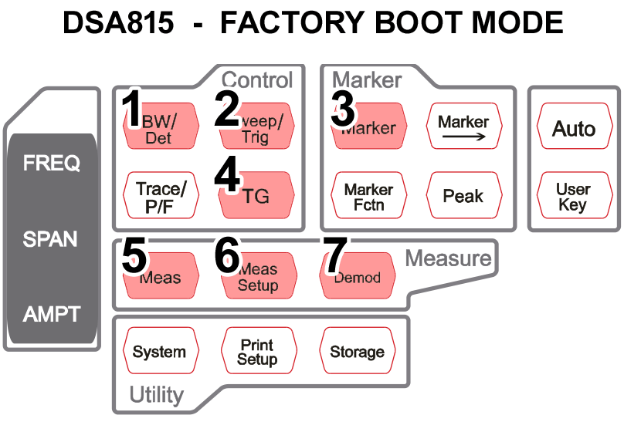
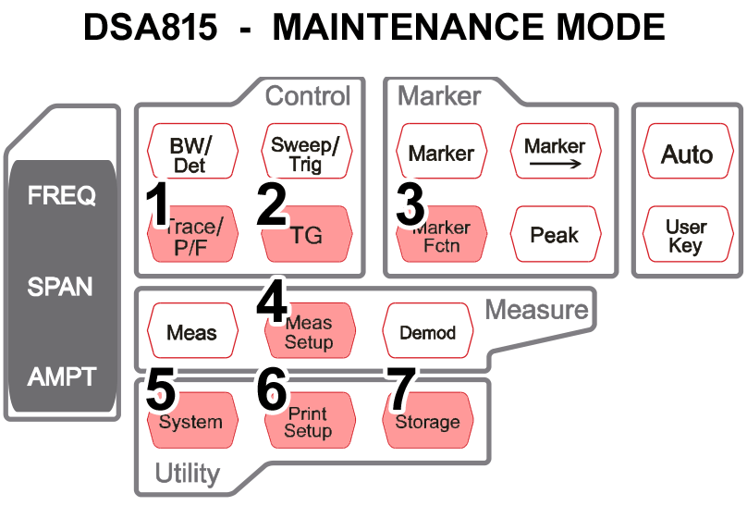

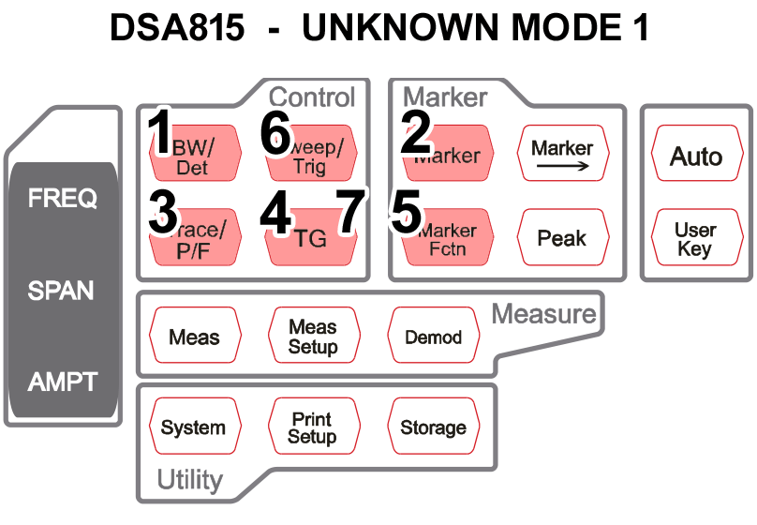
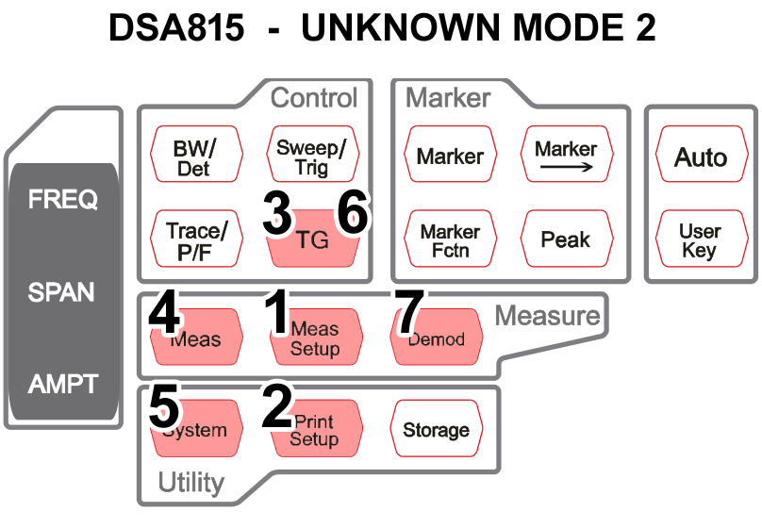

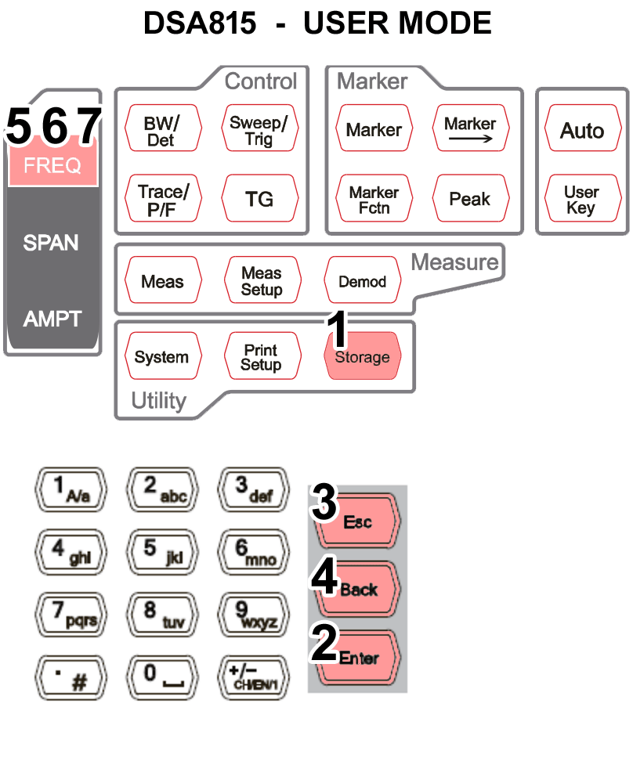

Correction file

\testcal4.cbl - 322 Bytes
00000000 39 93 3c 01 00 00 ff 11 00 00 43 42 4c 46 38 01 9“<...ÿ...CBLF8.
00000010 00 00 14 00 64 00 c0 00 00 00 00 00 00 00 01 00 ....d.À.........
00000020 00 00 43 4f 52 52 c0 00 00 00 4e 4f 4e 45 00 00 ..CORRÀ...NONE..
00000030 00 00 4e 4f 4e 45 00 00 00 00 4e 4f 4e 45 00 00 ..NONE....NONE..
00000040 00 00 4e 4f 4e 45 00 00 00 00 4e 4f 4e 45 00 00 ..NONE....NONE..
00000050 00 00 4e 4f 4e 45 00 00 00 00 4e 4f 4e 45 00 00 ..NONE....NONE..
00000060 00 00 4e 4f 4e 45 00 00 00 00 4e 4f 4e 45 00 00 ..NONE....NONE..
00000070 00 00 30 30 2e 30 31 2e 30 39 2e 30 30 2e 30 37 ..00.01.09.00.07
00000080 00 00 00 00 a0 c0 80 77 8e 06 00 00 00 00 00 00 .... À€wŽ.......
00000090 80 3f 00 c2 eb 0b 00 00 00 00 00 00 80 3f 00 a3 €?.Âë.......€?.£
000000a0 e1 11 00 00 00 00 00 00 80 3f 00 84 d7 17 00 00 á.......€?.„×...
000000b0 00 00 00 00 80 3f 00 65 cd 1d 00 00 00 00 00 00 ....€?.eÍ.......
000000c0 80 3f 00 46 c3 23 00 00 00 00 00 00 00 40 00 27 €?.FÃ#.......@.'
000000d0 b9 29 00 00 00 00 00 00 e0 40 00 08 af 2f 00 00 ¹)......à@..¯/..
000000e0 00 00 00 00 00 40 00 e9 a4 35 00 00 00 00 00 00 .....@.é¤5......
000000f0 00 40 00 ca 9a 3b 00 00 00 00 00 00 00 40 00 ab .@.Êš;.......@.«
00000100 90 41 00 00 00 00 00 00 40 40 00 8c 86 47 00 00 A......@@.Œ†G..
00000110 00 00 00 00 40 40 00 6d 7c 4d 00 00 00 00 00 00 ....@@.m|M......
00000120 40 40 00 4e 72 53 00 00 00 00 00 00 40 40 80 3e @@.NrS......@@€>
00000130 6d 56 00 00 00 00 00 00 80 c0 c0 ec 58 59 00 00 mV......€ÀÀìXY..
00000140 00 00 ..

testcal4.cbl - CorrTable

Point 1 110 MHz -5 dB
Point 2 200 MHz 1 dB
Point 3 300 MHz 1 dB
Point 4 400 MHz 1 dB
Point 5 500 MHz 1 dB
Point 6 600 MHz 1 dB
Point 7 700 MHz 2 dB
Point 8 800 MHz 7 dB
Point 9 900 MHz 2 dB
Point 10 1000 MHz 2 dB
Point 11 1100 MHz 2 dB
Point 12 1200 MHz 3 dB
Point 13 1300 MHz 3 dB
Point 14 1400 MHz 3 dB
Point 15 1450 MHz 3 dB
Point 16 1499 MHz -4 dB

Address 00000000 39 93 3c 01 = Is usually different per file, but not always.
Address 0000000A 43 42 4c 46 = Format identifier?
Address 0000000E 38 01 00 00 = 0x00000138 = 312 + 10 = 322 Bytes File size.
Address 00000016 c0 00 00 00 = 0x000000C0 = 192 Bytes Points data.
Address 00000022 43 4f 52 52 = „CORR“ = Correction data, Format identifier.
Address 00000026 c0 00 00 00 = 0x000000C0 = 192 Bytes Points data.
Address 00000072 30 30 2e 30 31 2e 30 39 2e 30 30 2e 30 37 = Firmware version.

Point 1 110 MHz -5 dB - 00000082 00 00 a0 c0 80 77 8e 06 00 00 00 00
Point 2 200 MHz 1 dB - 0000008E 00 00 80 3f 00 c2 eb 0b 00 00 00 00
.......
.......
.......

Point 1 - Address 00000082
Float 32 bit 00 00 a0 c0 = 0xC0A00000 = -5.0E0 = -5 dB
Integer 80 77 8e 06 = 0x068E7780 = 110000000 = 110 MHz
Unknown 00 00 00 00

Point 2 - Address 0000008E
Float 32 bit 00 00 80 3f = 0x3F800000 = 1.0E0 = 1 dB
Integer 00 c2 eb 0b = 0x0BEBC200 = 200000000 = 200 MHz
Unknown 00 00 00 00
.......
.......
.......

