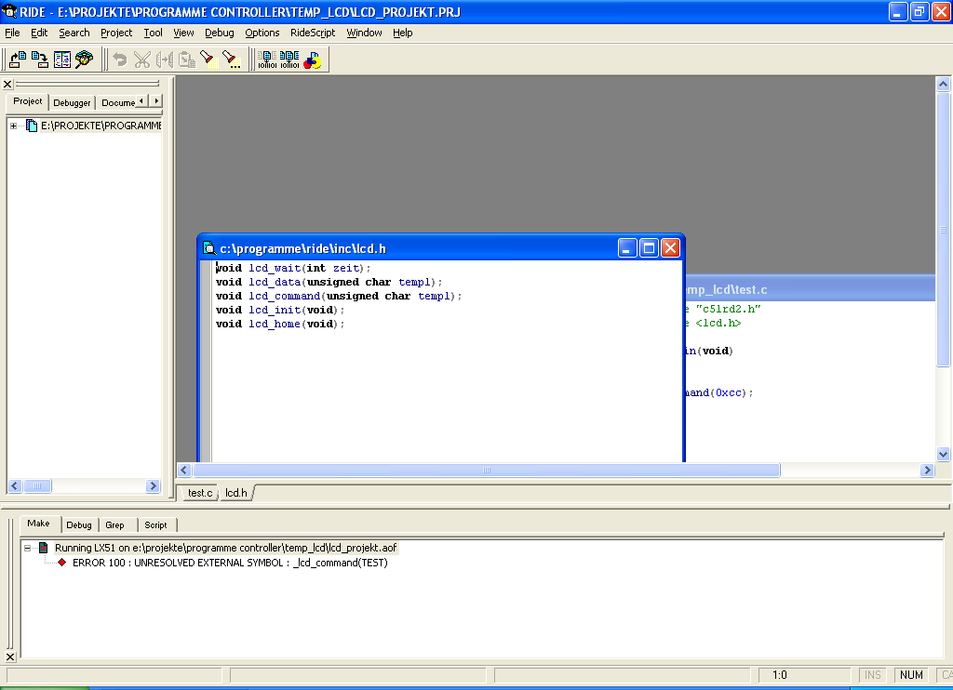

lcd.h

void lcd_wait(int zeit);
void lcd_data(unsigned char temp1);
void lcd_command(unsigned char temp1);
void lcd_init(void);
void lcd_home(void);

lcd.c

#include "c51rd2.h"
#define CLEAR_DISPLAY 0x01
#define CURSOR_HOME 0x02

/*
LCD Anschluß:
P1_0 --> LCD D4
P1_1 --> LCD D5
P1_2 --> LCD D6
P1_3 --> LCD D7
P1_4 --> RS
P1_5 --> R/W --> auf masse oder "0"
P1_6 --> E
P1_7
*/

//____________________________________LCD Wait_____________________________
void lcd_wait(int zeit)

{
int x,y=0;
for (x=0;x<=zeit;x++)
{
y=y+1; // keine Funktion --> NOP
}
}

//______________________________lcd Enable ___________________________

// _____________________Initialisierung__________________________________

void lcd_init(void)
{

P1 = 0x03; // 0b00000011

P1 = 0x03;

P1 = 0x03;

// 4bit-Modus einstellen
P1 = 0x02; // 0b00000010

// 4Bit / 2 Zeilen / 5x8
lcd_command(0x28); // 0b00101000

// Display ein / Cursor aus / kein Blinken
lcd_command(0x0C); // 0b00001100

// inkrement / kein Scrollen
lcd_command(0x04); // 0b00000100
}

/*
//_________________________________________Commando senden_______________

void lcd_command(unsigned char temp1)
{
unsigned char temp2 = temp1;

temp1 = temp1 >> 4; // oberes Nibble holen
temp1 = temp1 & 0x0F; // maskieren
P1 = temp1; // setzen

temp2 = temp2 & 0x0F; // unteres Nibble holen und maskieren
P1 = temp2; // setzen

lcd_wait (50);
}
*/

//______________________________LCD-Daten___________________________

void lcd_data(unsigned char temp1)
{
unsigned char temp2 = temp1;

temp1 = temp1 >> 4;
temp1 = temp1 & 0x0F;
P1 = temp1|0b00010000; // RS setzen und Wert

P1 = P1&0b11101111; //RS zurücksetzen

temp2 = temp2 & 0x0F;
P1 = temp2|0b00010000; // RS setzen und Wert

P1 = P1&0b11101111; //RS zurücksetzen

lcd_wait(50);
}

// Sendet den Befehl zur Löschung des Displays
void lcd_clear(void)
{
lcd_command(CLEAR_DISPLAY);
lcd_wait(100);
}

// Sendet den Befehl: Cursor Home
void lcd_home(void)
{
lcd_command(CURSOR_HOME);
lcd_wait(100);
}

test.c

#include "c51rd2.h"
#include <lcd.h>

void main(void)

{
lcd_command(0xcc);

}

