LAB 3: BIOPOTENTIALS (ECG, EMG)

In this lab, we will “upgrade” the instrumentation amplifier into an ECG amplifier. ECG is a bodily electrical signal with typical amplitude of 500 μV and a frequency range of 0.01 to 250 Hz. Thus the desired output from our ECG amplifier is a 5V maximum amplitude signal, with a frequency range of 0.5 to 100 Hz. Therefore, our amplifier will have a gain of 1000, and the filter will have a pass band of 0.5 to 100 Hz. We need to keep three important and basic functions of any biopotential amplifier in mind: patient protection, signal amplification, and signal filtering.

Differential and Instrumentation Amplifiers: Building Blocks for Biopotential Amplifiers.

In order to study Electrophysiology, we need to be able to record various biopotentials (i.e. ECG, EMG, EOG, EEG, etc…). The basic biopotential amplifier requires an appropriate amplitude amplification range as well as frequency range, and noise reduction. The basic building blocks of biopotential amplifiers are differential and instrumentation amplifiers. In this lab you will begin by designing and characterizing a single op-amp differential amplifier, and move on by adding a two op-amp input stage to complete a low-noise, high-gain instrumentation amplifier. You will save this amplifier as it will be the basic component in our ECG amplifier next week so make sure to implement a clean and uncluttered circuit.

Pre-lab:

- Review basic op-amp and filter circuits and define common mode gain, CMRR, and differential gain and why are they important?
- Provide schematic diagrams for a one op-amp differential-amplifier (use only common component values as given in Lab 1)
- Devise a method to test the common mode gains and rejection so that you are prepared for the lab.
- Provide schematic diagrams for the two op-amp input stage, and the complete instrumentation amplifier (Refer to Section 3.4 of theWebster book). Explain why we use the two-op amp input stage and it’s importance.

EXPERIMENT 3.1 (a): Differential Amplifier

- Construct a differential amplifier to the specifications listed below:
  - Differential Gain → 20
  - Common Mode Gain → As Low as possible
  - CMRR > 60 dB

- Find out the experimental characteristics of your circuit such as gain and CMRR. Try to reduce the common mode gain by using potentiometers to compensate for mismatched resistors.

- Use a function generator to provide the input signal and use the data acquisition and sample Lab View code provided, to record both the input and output. Save your results, they’ll be needed for the lab write up.

EXPERIMENT 3.1 (b): Instrumentation Amplifier

- First build the 2-opamp input stage of the instrumentation amplifier.

  - Input Stage Gain → 50
  - Common Mode Gain → 1
  - CMRR → About 30 dB
  - Input Impedance for both Op-Amps → 2M Ohms

- Verify and test the gain and CMRR of this input stage. Save this data for the lab write up.

- Next, Cascade the input stage with the differential amplifier from the first part.

- Experiment with this circuit to determine the actual gain and CMRR. Again save data for write up.

- You should have a total gain of 1000 and CMRR > 80 dB.

LAB REPORT #3.1

- Provide a final schematic of the instrumentation amplifier with all the component values labeled.

- Derive the differential gain, common mode gain, and CMRR in dB for both Parts 1 and 2.

- Discuss the two different designs, 1 op-amp & 2 op-amp input stage in terms of achievable gains, CMRR, and input impedances.

- List three or more reasons discussing the importance of using instrumentation amplifier for biopotential measurements (as compared to simple non-inverting amplifiers). Use your notes and book for help.

BONUS:
Look through Data Books (i.e. Motorola, National Semiconductor, HP, Texas Instruments, etc…) as well as web pages with Data Sheets (Digikey, Newark, etc…) to find and identify a commercially available one-chip instrumentation amplifier which out performs the one you built in Lab (i.e. better gain, CMRR, noise reduction, input impedance, patient protection, isolation, etc…).

Additional references:

Horowitz and Hill, The art of electronics.

Chapter 3 of Medical Instrumentation by Webster.

EXPERIMENT 3.2: ECG Amplifier

The following describes the ECG amplifier designed in this laboratory. The first three op-amps comprise the instrumentation amplifier necessary to obtain the biosignal and to reject noise (as seen in Lab 1). The fourth and fifth op-amps are designed to be high- and low-pass filters with cut-off frequencies of 0.5 Hz and 100 Hz, respectively. The last op-amp is a comparator designed to trigger an LED during the QRS-wave portion of the biosignal. Between the output of the fifth op-amp and in the input of the sixth op-amp is the output signal of the ECG. The diodes at the inputs of the first and second op-amps are designed to protect the circuit from high voltage.

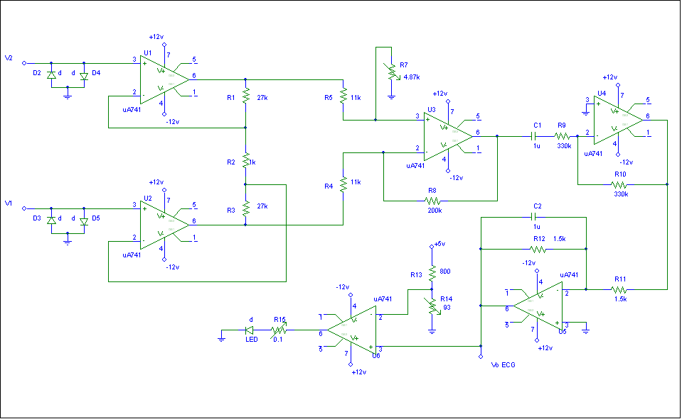

EXPERIMENT # 3.2:
- Construct and characterize a band pass filter with the following specifications:
- Active band pass filter
- Unity gain in pass band
- Pass band: 0.5 to 100 Hz
Record the experimental values for the gain and corner frequencies of the filter.
- Ask the TA for electrodes. It is important to establish a good electrical contact between the electrode and skin. Place one electrode near each shoulder and a reference ground (third electrode) on the ankle of the right leg.
- You will be using BioBench to record your ECG. Connect the output of your amplifier to the DAQ card inputs. Hook up the electrodes to your circuit and record your ECG with the lead wires twisted. Record your own ECG!
- Now explore sources of electrical interference. A) Try jogging or moving, and notice the source of artifact. B) Notice what is the most prevalent high frequency interference signal. Try to record ECG with electrode wires twisted. Does it reduce interference? C) Now flex your muscles (curl biceps or squeeze two arms against each other). What is the source and the approximate frequency of this interference?

LAB REPORT #3.3

- Provide a final schematic of the instrumentation amplifier with all the component values labeled.
  - Accurately calculate the differential gain, and report the measured common mode gain, and CMRR in dB.
  - Accurately calculate and compare with the experimental recording the frequency response of the amplifier (you only need to look at the pass band, and then identify the cutoff frequency where the gain is 0.707*the pass band value.

- Plot/print ECG recording with a) no noise, b) movement/motion artifact, c) 60 Hz power line noise.

HOMEWORK # 3

.
- What modifications are required to use this circuit to measure EMG?
- As you know, this circuit is the core of all commercial ECG monitors. What features of the commercial ECG monitors make them more expensive than the cost of a few chips and resistors/capacitors (limit answer to 200 words)?
- List three or more reasons discussing the importance of using instrumentation amplifier for biopotential measurements (as compared to simple non-inverting amplifiers). Use your notes and book for help
- In addition, describe other means of reducing electrical interference in biomedical experiments. That is, in the laboratory what were the different causes of interference in your ECG recording? How could you have reduced them? Why does the twisting of the wire pair produce a difference in the recorded signal?
- Design a QRS complex detection circuit. This circuit would have a differentiator, a rectifier and a comparator. Where (what medical applications) could such a circuit be used for?
- Design a circuit to detect heart rate (i.e. detect the QRS compex). Start with a block diagram. Hint: you will need to differentiate/filter the signal, rectify it and then compare it to a threshold.
- What is tachycardia? What is bradycardia? How would you design an alarm circuit to detect the two?
- Long-term cardiac monitors sometimes have circuitry that activates an alarm when the electrode connection is broken or otherwise compromised. Come up with an idea for a circuit that performs this function and briefly explain how it works. You do not have to design the circuit or the ECG amplifier – just indicate where they should be hooked up to your circuit.
- Cardiac monitors in the hospital have to be used on patients who might have to be defibrillated. Hence the ECG amplifier must withstand a large electrical shock of thousand volt or more. Describe the circuit or method for “protection” against defibrillator shocks.

