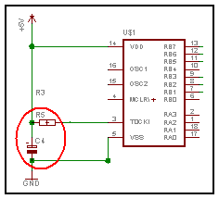R5= 10K C4=100µF

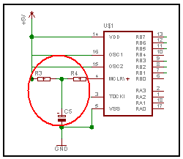R3= 10K R4= 100 C5=10µF

