#ASSEMBLER <80C32X2>
;**************************************************************************
;Wieviel mal muß das Busyflag abgefragt werden? Dieses Program zählt die
;Anzahl der Abfragen bei der letzten LCD-Aktion und speichert das Maximum,
;um es in regelmässigen Abständen anzuzeigen. LCD16X1 an Port1. DB7-4 an
;P1.7-4. E, RW, RS an P1.3-1. P1.0 nicht angeschlossen.
;Resultat - bei 1,8432Mhz 18 Abfragen, bei 24Mhz 230 Abfragen.
;Assembler – HASM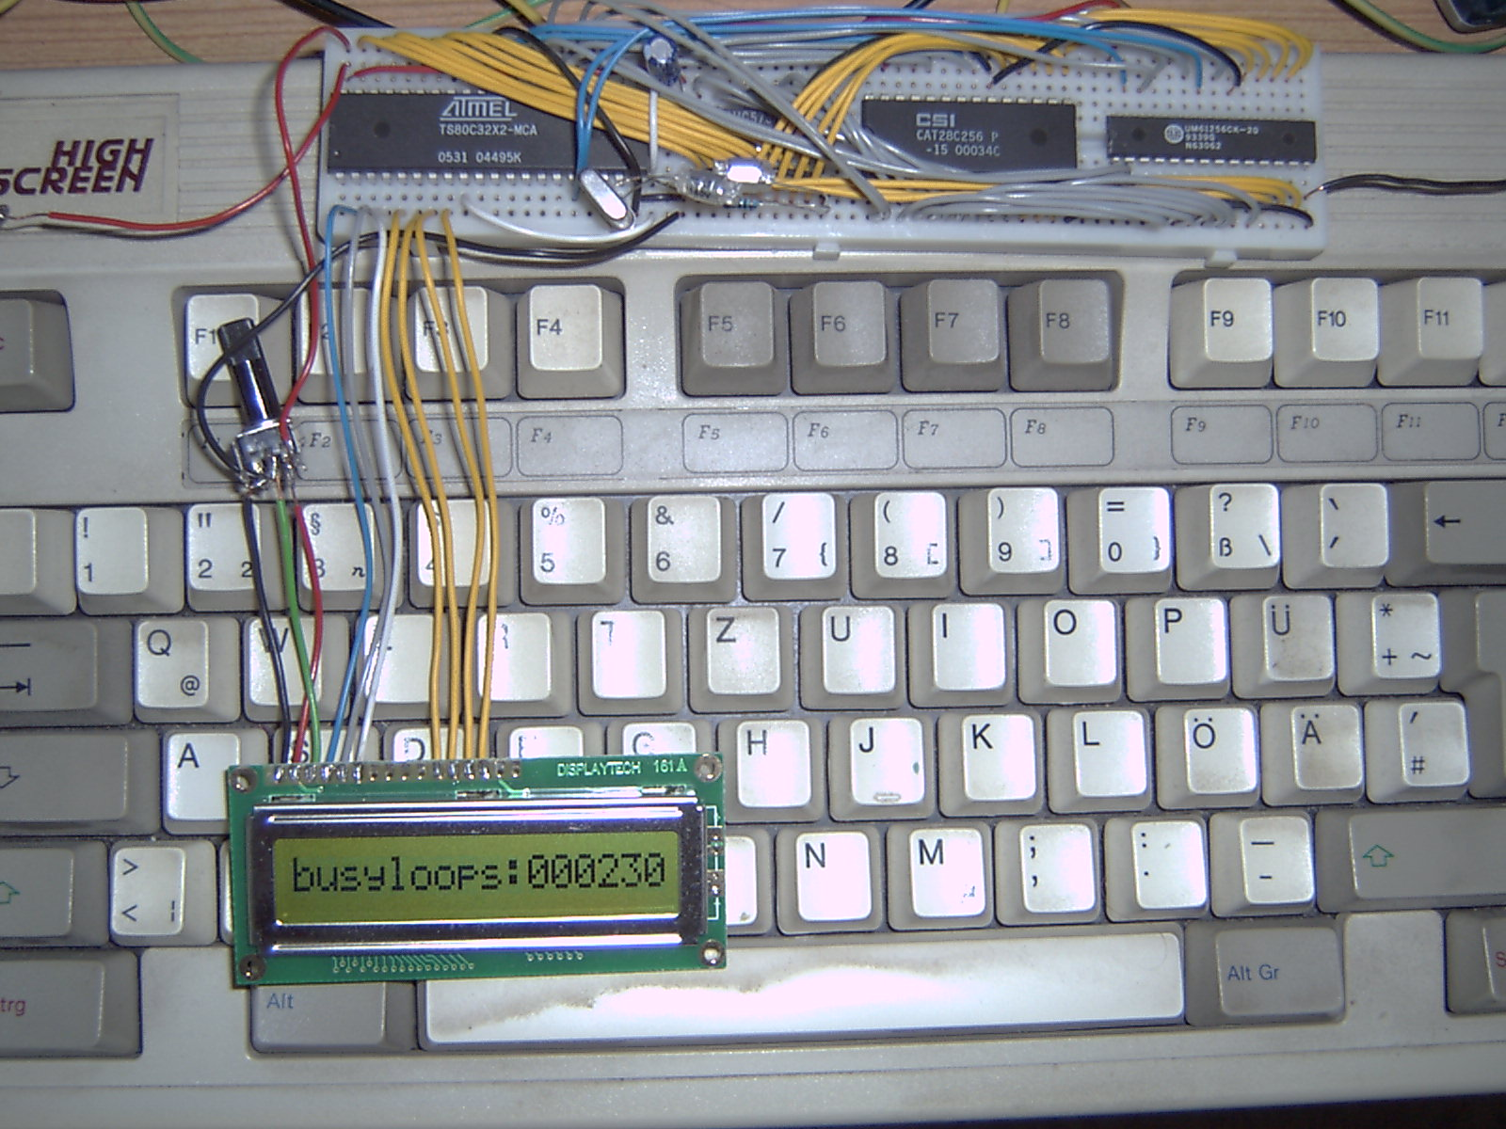
;**************************************************************************

ACC EQU 0E0h
PAUSE EQU F0
MAXH EQU 50h
MAXL EQU 51h

org 0
sjmp L002

org 3
inc DPTR
reti

org 0bh
inc R7
cjne R7,#2,L000
sjmp _anzeige
L000 reti

org 1bh
clr PAUSE
reti

_anzeige mov A,#58h
L001 cjne A,TH0,L001 ;Sekunde voll machen
clr TR0 ;Stop Timer
mov 33h,MAXL
mov 32h,MAXH
mov 31h,#0
mov 30h,#0
acall _bintodec
mov A,#42h
acall _displadr
mov A,40h
acall _displram
mov A,41h
acall _displram
mov A,42h
acall _displram
mov A,43h
acall _displram
mov A,44h
acall _displram
mov A,45h
acall _displram
mov R7,#0 ;Reset Timer
mov TH0,#0
mov TL0,#0
setb TR0 ;Start Timer
reti

L002 orl IE,#10001010b ;Enable All+Tim1+Tim0
orl TMOD,#1 ;Timer0 / 16Bit
mov SP,#60h
mov MAXH,#0 ;Z„hler fr Busyflagabfragen
mov MAXL,#0
acall _init_lcd
clr A
acall _displadr
mov DPTR,#L011
acall _displcon
mov A,#40h
acall _displadr
mov DPTR,#L012
acall _displcon
mov R7,#0
orl TCON,#00010001b ;Start Timer0 / neg. Flanke
L003 orl PCON,#1
sjmp L003

_init_lcd acall _pause
mov P1,#00111001b ;Function set (8-bit Interface)
clr P1.3 ;Daten bernehmen (Enable-Pin)
acall _pause

mov P1,#00111001b ;Function set w.o.
clr P1.3
acall _pause

mov P1,#00111001b ;Function set w.o.
clr P1.3
acall _pause

mov P1,#00101001b ;4-Bit Interface setzen
clr P1.3
acall _pause ;**** bis hier groáe pause n”tig!

mov P1,#00101001b ;4-Bit Interface setzen w.o. +
clr P1.3
mov P1,#10111001b ;2-Zeilen Display+5X7 Zeichenfont
clr P1.3
acall _busy

mov P1,#00001001b ;Display on +
clr P1.3
mov P1,#11001001b ;Cursor unsichtbar+Blinken aus
clr P1.3
acall _busy

mov P1,#00001001b ;Display l”schen
clr P1.3
mov P1,#00011001b
clr P1.3
acall _busy

mov P1,#00001001b ;Entry mode set
clr P1.3
mov P1,#01101001b ;nach rechts schreiben+nicht schieben
clr P1.3
acall _busy ;Initialisierung erster Teil

mov P1,#01001001b ;CG-RAM-Adresse setzen/0-0
clr P1.3
mov P1,#00001001b
clr P1.3
acall _busy

mov P1,#11101011b ;Daten ins CG-RAM schreiben
clr P1.3
mov P1,#10101011b ; „-Pnktchen
clr P1.3
acall _busy

mov P1,#01001001b ;CG-RAM-Adresse setzen/0-1
clr P1.3
mov P1,#00011001b
clr P1.3
acall _busy

mov P1,#11101011b ;Daten ins CG-RAM schreiben
clr P1.3
mov P1,#00001011b ; Leerzeile darunter
clr P1.3
acall _busy

mov P1,#01001001b ;CG-RAM-Adresse setzen/0-2
clr P1.3
mov P1,#00101001b
clr P1.3
acall _busy

mov P1,#11101011b ;Daten ins CG-RAM schreiben
clr P1.3
mov P1,#11101011b ; a-Punkte
clr P1.3
acall _busy

mov P1,#01001001b ;CG-RAM-Adresse setzen/0-3
clr P1.3
mov P1,#00111001b
clr P1.3
acall _busy

mov P1,#11101011b ;Daten ins CG-RAM schreiben
clr P1.3
mov P1,#00011011b
clr P1.3
acall _busy

mov P1,#01001001b ;CG-RAM-Adresse setzen/0-4
clr P1.3
mov P1,#01001001b
clr P1.3
acall _busy

mov P1,#11101011b ;Daten ins CG-RAM schreiben
clr P1.3
mov P1,#11111011b
clr P1.3
acall _busy

mov P1,#01001001b ;CG-RAM-Adresse setzen/0-5
clr P1.3
mov P1,#01011001b
clr P1.3
acall _busy

mov P1,#11111011b ;Daten ins CG-RAM schreiben
clr P1.3
mov P1,#00011011b
clr P1.3
acall _busy

mov P1,#01001001b ;CG-RAM-Adresse setzen/0-6
clr P1.3
mov P1,#01101001b
clr P1.3
acall _busy

mov P1,#11101011b ;Daten ins CG-RAM schreiben
clr P1.3
mov P1,#11111011b
clr P1.3
acall _busy

mov P1,#01001001b ;CG-RAM-Adresse setzen/0-7
clr P1.3
mov P1,#01111001b
clr P1.3
acall _busy

mov P1,#11101011b ;Daten ins CG-RAM schreiben
clr P1.3
mov P1,#00001011b
clr P1.3
acall _busy

mov P1,#01001001b ;CG-RAM-Adresse setzen/1-0
clr P1.3
mov P1,#10001001b
clr P1.3
acall _busy

mov P1,#11101011b ;Daten ins CG-RAM schreiben
clr P1.3
mov P1,#10101011b ; ”-Pnktchen
clr P1.3
acall _busy

mov P1,#01001001b ;CG-RAM-Adresse setzen/1-1
clr P1.3
mov P1,#10011001b
clr P1.3
acall _busy

mov P1,#11101011b ;Daten ins CG-RAM schreiben
clr P1.3
mov P1,#00001011b ; Leerzeile darunter
clr P1.3
acall _busy

mov P1,#01001001b ;CG-RAM-Adresse setzen/1-2
clr P1.3
mov P1,#10101001b
clr P1.3
acall _busy

mov P1,#11101011b ;Daten ins CG-RAM schreiben
clr P1.3
mov P1,#11101011b ; o-Punkte
clr P1.3
acall _busy

mov P1,#01001001b ;CG-RAM-Adresse setzen/1-3
clr P1.3
mov P1,#10111001b
clr P1.3
acall _busy

mov P1,#11111011b ;Daten ins CG-RAM schreiben
clr P1.3
mov P1,#00011011b
clr P1.3
acall _busy

mov P1,#01001001b ;CG-RAM-Adresse setzen/1-4
clr P1.3
mov P1,#11001001b
clr P1.3
acall _busy

mov P1,#11111011b ;Daten ins CG-RAM schreiben
clr P1.3
mov P1,#00011011b
clr P1.3
acall _busy

mov P1,#01001001b ;CG-RAM-Adresse setzen/1-5
clr P1.3
mov P1,#11011001b
clr P1.3
acall _busy

mov P1,#11111011b ;Daten ins CG-RAM schreiben
clr P1.3
mov P1,#00011011b
clr P1.3
acall _busy

mov P1,#01001001b ;CG-RAM-Adresse setzen/1-6
clr P1.3
mov P1,#11101001b
clr P1.3
acall _busy

mov P1,#11101011b ;Daten ins CG-RAM schreiben
clr P1.3
mov P1,#11101011b
clr P1.3
acall _busy

mov P1,#01001001b ;CG-RAM-Adresse setzen/1-7
clr P1.3
mov P1,#11111001b
clr P1.3
acall _busy

mov P1,#11101011b ;Daten ins CG-RAM schreiben
clr P1.3
mov P1,#00001011b
clr P1.3
acall _busy

mov P1,#01011001b ;CG-RAM-Adresse setzen/2-0
clr P1.3
mov P1,#00001001b
clr P1.3
acall _busy

mov P1,#11101011b ;Daten ins CG-RAM schreiben
clr P1.3
mov P1,#10101011b ; -Pnktchen
clr P1.3
acall _busy

mov P1,#01011001b ;CG-RAM-Adresse setzen/2-1
clr P1.3
mov P1,#00011001b
clr P1.3
acall _busy

mov P1,#11101011b ;Daten ins CG-RAM schreiben
clr P1.3
mov P1,#00001011b ; Leerzeile darunter
clr P1.3
acall _busy

mov P1,#01011001b ;CG-RAM-Adresse setzen/2-2
clr P1.3
mov P1,#00101001b
clr P1.3
acall _busy

mov P1,#11111011b ;Daten ins CG-RAM schreiben
clr P1.3
mov P1,#00011011b ; u-Punkte
clr P1.3
acall _busy

mov P1,#01011001b ;CG-RAM-Adresse setzen/2-3
clr P1.3
mov P1,#00111001b
clr P1.3
acall _busy

mov P1,#11111011b ;Daten ins CG-RAM schreiben
clr P1.3
mov P1,#00011011b
clr P1.3
acall _busy

mov P1,#01011001b ;CG-RAM-Adresse setzen/2-4
clr P1.3
mov P1,#01001001b
clr P1.3
acall _busy

mov P1,#11111011b ;Daten ins CG-RAM schreiben
clr P1.3
mov P1,#00011011b
clr P1.3
acall _busy

mov P1,#01011001b ;CG-RAM-Adresse setzen/2-5
clr P1.3
mov P1,#01011001b
clr P1.3
acall _busy

mov P1,#11111011b ;Daten ins CG-RAM schreiben
clr P1.3
mov P1,#00111011b
clr P1.3
acall _busy

mov P1,#01011001b ;CG-RAM-Adresse setzen/2-6
clr P1.3
mov P1,#01101001b
clr P1.3
acall _busy

mov P1,#11101011b ;Daten ins CG-RAM schreiben
clr P1.3
mov P1,#11011011b
clr P1.3
acall _busy

mov P1,#01011001b ;CG-RAM-Adresse setzen/2-7
clr P1.3
mov P1,#01111001b
clr P1.3
acall _busy

mov P1,#11101011b ;Daten ins CG-RAM schreiben
clr P1.3
mov P1,#00001011b
clr P1.3
acall _busy

mov P1,#01011001b ;CG-RAM-Adresse setzen/3-0
clr P1.3
mov P1,#10001001b
clr P1.3
acall _busy

mov P1,#11101011b ;Daten ins CG-RAM schreiben
clr P1.3
mov P1,#11101011b ; á
clr P1.3
acall _busy

mov P1,#01011001b ;CG-RAM-Adresse setzen/3-1
clr P1.3
mov P1,#10011001b
clr P1.3
acall _busy

mov P1,#11111011b ;Daten ins CG-RAM schreiben
clr P1.3
mov P1,#00011011b
clr P1.3
acall _busy

mov P1,#01011001b ;CG-RAM-Adresse setzen/3-2
clr P1.3
mov P1,#10101001b
clr P1.3
acall _busy

mov P1,#11111011b ;Daten ins CG-RAM schreiben
clr P1.3
mov P1,#11101011b
clr P1.3
acall _busy

mov P1,#01011001b ;CG-RAM-Adresse setzen/3-3
clr P1.3
mov P1,#10111001b
clr P1.3
acall _busy

mov P1,#11111011b ;Daten ins CG-RAM schreiben
clr P1.3
mov P1,#00011011b
clr P1.3
acall _busy

mov P1,#01011001b ;CG-RAM-Adresse setzen/3-4
clr P1.3
mov P1,#11001001b
clr P1.3
acall _busy

mov P1,#11111011b ;Daten ins CG-RAM schreiben
clr P1.3
mov P1,#11101011b
clr P1.3
acall _busy

mov P1,#01011001b ;CG-RAM-Adresse setzen/3-5
clr P1.3
mov P1,#11011001b
clr P1.3
acall _busy

mov P1,#11111011b ;Daten ins CG-RAM schreiben
clr P1.3
mov P1,#00001011b
clr P1.3
acall _busy

mov P1,#01011001b ;CG-RAM-Adresse setzen/3-6
clr P1.3
mov P1,#11101001b
clr P1.3
acall _busy

mov P1,#11111011b ;Daten ins CG-RAM schreiben
clr P1.3
mov P1,#00001011b
clr P1.3
acall _busy

mov P1,#01011001b ;CG-RAM-Adresse setzen/3-7
clr P1.3
mov P1,#11111001b
clr P1.3
acall _busy

mov P1,#11101011b ;Daten ins CG-RAM schreiben
clr P1.3
mov P1,#00001011b
clr P1.3
acall _busy
ret ;Initialisierung Ende

_rethome mov P1,#00001001b ;Return home
clr P1.3
mov P1,#00111001b
clr P1.3
acall _busy
ret

_displclr mov P1,#00001001b ;Display l”schen
clr P1.3
mov P1,#00011001b
clr P1.3
acall _busy
ret

_disploff mov P1,#00001001b ;Display off
clr P1.3
mov P1,#10001001b
clr P1.3
acall _busy
ret

_displon mov P1,#00001001b ;Display on
clr P1.3
mov P1,#11001001b
clr P1.3
acall _busy
ret

_shiftre mov P1,#00011001b ;Display-Shift/rechts
clr P1.3
mov P1,#11111001b
clr P1.3
acall _busy
ret

_shiftli mov P1,#00011001b ;Display-Shift/links
clr P1.3
mov P1,#10111001b
clr P1.3
acall _busy
ret

_displadr push ACC
anl A,#01110000b
orl A,#10001001b ;Bit7 immer gesetzt
mov P1,A
clr P1.3
pop ACC
swap A
anl A,#11110000b
orl A,#00001001b
mov P1,A
clr P1.3
acall _busy
ret

_displcon clr A
L004 push ACC
movc A,@A+DPTR
push ACC
anl A,#11110000b
orl A,#00001011b
mov P1,A ;Daten ins DD-RAM schreiben
clr P1.3
pop ACC
swap A
anl A,#11110000b
orl A,#00001011b
mov P1,A
clr P1.3
acall _busy
pop ACC
inc A
cjne A,#8,L004
ret

_displram push ACC
anl A,#11110000b
orl A,#00001011b
mov P1,A
clr P1.3
pop ACC
swap A
anl A,#11110000b
orl A,#00001011b
mov P1,A
clr P1.3
acall _busy
ret

_pause setb PAUSE
setb TR1
L005 jb PAUSE,L005
clr TR1
ret

_busy inc AUXR1 ;Datapointer1/Z„hler Busyflagabfragen
mov DPTR,#0 ;Z„hler resetten
mov P1,#11110101b
L006 setb P1.3
nop
mov C,P1.7 ;Busy-Flag lesen
clr P1.3
nop
nop
setb P1.3
nop
nop
clr P1.3
inc DPTR ;Anzahl Durchg„nge
jc L006
mov A,DPH ;neues Maximum?
cjne A,MAXH,L008
mov A,DPL ;DPH = MAXH
cjne A,MAXL,L007
dec AUXR1 ;DPL = MAXL
ret
L007 jc L009 ;DPL < MAXL
mov MAXL,A ;DPL > MAXL
dec AUXR1
ret
L008 jc L009 ;DPH < MAXH
mov MAXH,A ;DPH > MAXH
mov A,DPL
mov MAXL,A
L009 dec AUXR1 ;Datapointer0
ret

;30h-33h reserviert fr die 32bit-Variable
;34h-37h reserviert fr den Zwischenspeicher
;38h-3bh reserviert fr die Summanden - Milliarde ... Eins
;3ch-45h reserviert fr die Dezimalstellen
;alles im Big-Endian-Format(High-Byte zuerst)

_bintodec mov R3,#3ch ;Dezimalstellen-Ablage
mov R0,#33h ;Einerkomplement bilden
mov A,@R0
cpl A
mov @R0,A
dec R0
mov A,@R0
cpl A
mov @R0,A
dec R0
mov A,@R0
cpl A
mov @R0,A
dec R0
mov A,@R0
cpl A
mov @R0,A
mov R0,#3bh ;Milliarde
mov @R0,#00h
dec R0
mov @R0,#0cah
dec R0
mov @R0,#9ah
dec R0
mov @R0,#3bh
acall _add32 ;Addition/Anzahl Milliarden ermitteln
mov R0,#3bh ;Hundert-Millionen
mov @R0,#00h
dec R0
mov @R0,#0e1h
dec R0
mov @R0,#0f5h
dec R0
mov @R0,#05h
acall _add32 ;Addition/Anzahl Hundert-Millionen
mov R0,#3bh ;Zehn-Millionen
mov @R0,#80h
dec R0
mov @R0,#96h
dec R0
mov @R0,#98h
dec R0
mov @R0,#00h
acall _add32 ;Addition/Anzahl Zehn-Millionen
mov R0,#3bh ;Millionen
mov @R0,#40h
dec R0
mov @R0,#42h
dec R0
mov @R0,#0fh
dec R0
mov @R0,#00h
acall _add32 ;Addition/Anzahl Millionen
mov R0,#3bh ;Hundert-Tausend
mov @R0,#0a0h
dec R0
mov @R0,#86h
dec R0
mov @R0,#01h
dec R0
mov @R0,#00h
acall _add32 ;Addition/Anzahl Hundert-Tausender
mov R0,#3bh ;Zehn-Tausend
mov @R0,#10h
dec R0
mov @R0,#27h
dec R0
mov @R0,#00h
dec R0
mov @R0,#00h
acall _add32 ;Addition/Anzahl Zehn-Tausender
mov R0,#3bh ;Tausend
mov @R0,#0e8h
dec R0
mov @R0,#03h
dec R0
mov @R0,#00h
dec R0
mov @R0,#00h
acall _add32 ;Addition/Anzahl Tausender
mov R0,#3bh ;Hundert
mov @R0,#64h
dec R0
mov @R0,#00h
dec R0
mov @R0,#00h
dec R0
mov @R0,#00h
acall _add32 ;Addition/Anzahl Hunderter
mov R0,#3bh ;Zehn
mov @R0,#0ah
dec R0
mov @R0,#00h
dec R0
mov @R0,#00h
dec R0
mov @R0,#00h
acall _add32 ;Addition/Anzahl Zehner
mov R0,#3bh ;Einer
mov @R0,#01h
dec R0
mov @R0,#00h
dec R0
mov @R0,#00h
dec R0
mov @R0,#00h
acall _add32 ;Addition/Anzahl Einer
ret
_add32 mov R2,#-1 ;Dezimal-Ziffer
L010 acall _save ;alten Wert retten
mov R0,#33h
mov R1,#3bh
inc R2
mov A,@R0
add A,@R1
mov @R0,A
dec R0
dec R1
mov A,@R0
addc A,@R1
mov @R0,A
dec R0
dec R1
mov A,@R0
addc A,@R1
mov @R0,A
dec R0
dec R1
mov A,@R0
addc A,@R1
mov @R0,A
jnc L010
acall _restore ;alten Wert restaurieren
mov A,R3 ;Dezimalstellen-Ablage
mov R0,A
mov A,R2 ;Dezimal-Ziffer
add A,#30h ;ASCII-formatieren
mov @R0,A ;ablegen
inc R3
ret
_save mov R0,#33h
mov R1,#37h
mov A,@R0
mov @R1,A
dec R0
dec R1
mov A,@R0
mov @R1,A
dec R0
dec R1
mov A,@R0
mov @R1,A
dec R0
dec R1
mov A,@R0
mov @R1,A
ret
_restore mov R0,#33h
mov R1,#37h
mov A,@R1
mov @R0,A
dec R0
dec R1
mov A,@R1
mov @R0,A
dec R0
dec R1
mov A,@R1
mov @R0,A
dec R0
dec R1
mov A,@R1
mov @R0,A
ret

L011 db "busyloop"
L012 db "s: "

Quelle für Unterprogramm _busy(ohne Zähler)saved from url=(0057)http://home.comcast.net/~aa0zz/PICelmer/code/PEGen5-2.asm
Quelle sonst: Verfasser (Thomas Strauß) zur allgemeinen Verwendung

