Das Programm

* FLASH.C - LED Flasher for Phytecs Rapid Development Kits */

#include <XC167.h> /* special function register for XC161 */

sbit P9_0 = P9^0; /* declare portpin to use */
sbit DP9_0 = DP9^0; /* declare direction bit to use */

void wait (void) { /* wait function */
; /* only to delay for LED flashes */
}

void main (void) {
unsigned long i=0; /* delay var */

DP9_0 = 1; /* init direction to output */
while (1) /* loop forever */
{ /* An embedded program does not stop */

P9_0 = 1; /* output to LED port */
for (i=0; i<500000; i++) { /* delay for 150000 counts */
wait (); /* call wait function */
}

P9_0 = 1; /* output to LED port */
for (i=0; i<250000; i++) { /* delay for 150000 counts */
wait (); /* call wait function */
}
}

nach dem comilieren
so sieht mein Projekt
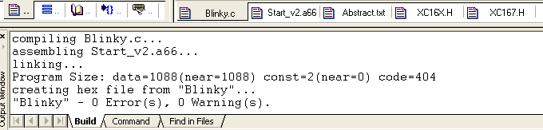

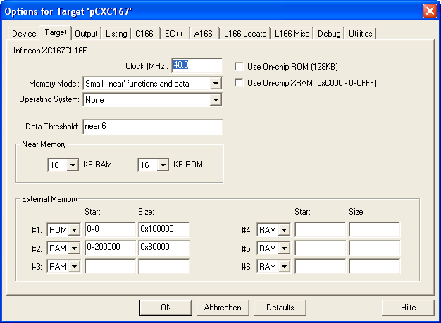
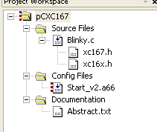 So sieht mein Projekt aus

