How to unlock an IPhone ☺

Step 1
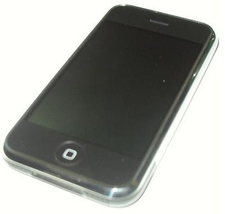
First, I would like to say thanks again to gray, iProof, dinopio, lazyc0der, anonymous, the dev team, nightwatch, and everyone who donated. Without them, there would be no unlock today, and I surely wouldn't be up at 8AM.
Second, you may brick your iPhone using this tutorial. YOU ARE WARNED.
Okay on to the actual step. Remove the black part, the three screws, and the aluminum case. Disconnect the wire connecting the phone to the case. Do not remove anything else. Comment on these posts if you are with me so far. Once we get a good number of comments I'll move on.

Step 2
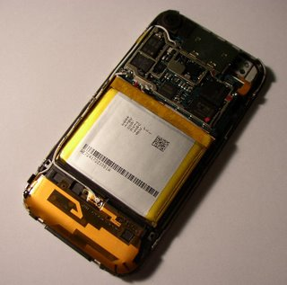
Also remove the metal cover over the comm board. This is all the disassembly you have to do. If you feel like being safe, desolder the battery red lead. I didn't :)

Step 3
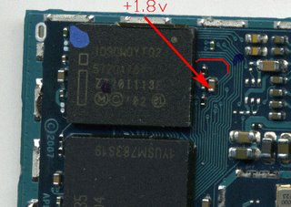
The red line is covering the A17 trace. In order to trick the chip into thinking the flash is erased in the correct section, you will need to pull this high. Scrape away at the trace with something like a multimeter probe. Then solder a very thin wire to it. Be very careful. Only scrape away at that solder mask above that one trace. YOU DO NOT WANT TO BREAK THE TRACE. This is the hardest step in the whole process; the rest is cake. Also solder a wire to the 1.8v line. Connect to wire coming from the trace and the wire coming from the 1.8v to your unlock switch. Be careful, you only get one chance to do this right. Thanks again to Nick Chernyy for the picture.

My Finished Step 3
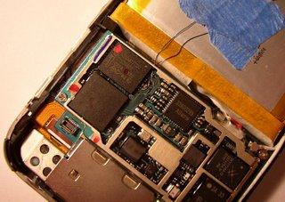
Hopefully yours will look like this.

Zoomed In Step 3
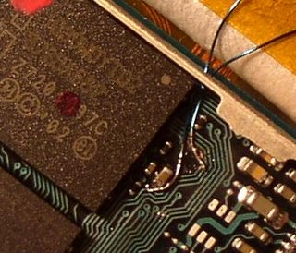
You can do it. I believe in you.

Step 4
Ok, time to test what you just soldered. First use the continuity check on a multimeter to make sure the wires aren't shorting to ground or to each other. Make sure your switch is in the off position. Power up your iPhone. Hopefully it didn't smoke :) Now go into minicom to tty.baseband and send a few commands, AT a few times will do. It should respond OK. Now flip your switch, the baseband should stop responding. Even when you flip it back, the baseband still shouldn't respond. Be sure your switch is off, then open another ssh and run "bbupdater -v" You can get bbupdater off the ramdisk. This should reset the baseband, and minicom should start working again. If it did this, your soldering is most likely good, and you are ready to actually start unlocking your phone!!!

Step 5
If it passed the checks in step 4, congratulate yourself. You are a pro solderer. Go eat lunch. If not, don't worry yet. I must've thought I bricked my phone 100 times. First of all, to power up your phone you don't need to reconnect the case with the power button. Just connect it with USB, it'll power itself up. Secondly, don't waste time compiling minicom. Download the binary here, and termcap here.

Step 6
Now, with the switch off, your baseband should be working perfectly. Here you should take a NOR dump of your phone. The dev team's NORDumper is a great way to do this. This is good to have in case something goes wrong. You can extract the firmware from this as well, which we'll get to later.

A Little Motivation
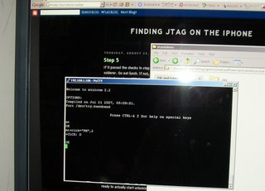
This is the world's second (outside super secret apple vault) unlocked iPhone.

Think of how pretty it'll be...
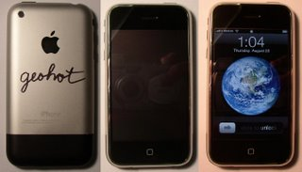

Step 7
So here is the first tool release, iEraser. This erases the current firmware on your modem. Don't worry, you can always put it back with bbupdater. Here how the bootrom check works; it reads from 0xA0000030 0xA000A5A0 0xA0015C58 0xA0017370 and all these addresses must read as blank, or 0xFFFFFFFF. When you erase flash, it becoms 0xFFFFFFFF. But you can't erase those locations, because they are in the bootloader. So thats where the testpoint comes in. Pulling A17 high hardware OR's the address bus with 0x00040000(offset one because data bus is 16 bit) So the bootrom instead checks locations 0xA0040030 0xA004A5A0 0xA0045C58 0xA0047370, which are in the main firmware and can be erased. Pretty genius :)
To use this tool, you need the secpack from your modems version. The erase of this section is protected. Check the modem version in Settings->About. It'll either be 3.12(1.0) or 3.14(1.0.1 and 1.0.2). You need the ramdisk which cooresponds to your version. Then go into "/usr/local/standalone/firmware" and get the ICE*.fls file. Extract 0x1a4-0x9a4 and save it in a file called secpack and place it in the same directory as the ieraser tool. Run ieraser. This should erase the modem firmware and leave you one more step on your way to unlocking.
STEP 8
Now its time to patch the firmware. Thanks to gray for finding these patches, this required some very complicated reversing. First, you need to extract the firmware from your nor dump. The range you need is 0x20000-0x304000. Save this file as "nor". The patches you need to apply are as follows. These are offsets from the begininning of the file to saved as "nor". Choose your version, and patch.
3.12: (213740): 04 00 a0 e1 -> 00 00 a0 e3
3.14: (215148): 04 00 a0 e1 -> 00 00 a0 e3
Resave the file nor, you'll need it soon...

Step 9
The final tool is iUnlocker. This tool uploads a small program, "testcode.bb", to the baseband using the bootrom exploit. This program needs to be in a dir with "nor", the file you obtained in the last step. You need to have the switch on when running this program. This will download and run the code in "testcode.bb" Then the program will stop and ask to to turn off the switch. Do so. You type any character then hit enter. The nor download starts right away. When the counter reaches 0x2E4000, it is done. Run "bbupdater -v". Hopefully it will return the xgendata. If is does, the nor upload was successful.

Step 10: The Last One
minicom into /dev/tty.baseband. If you already used up your attempt counter, the phone should already be unlocked. If not just run 'AT+CLCK="PN",0,"00000000". That will unlock the phone for sure. Run 'AT+CLCK="PN",2'. It should finally return 0!!!
Your phone is now unlocked. Exit minicom and copy the CommCenter plist back to its place. Reboot. iASign. And enjoy your unlocked iPhone.

Postmortem
So if you follow these steps, you should have an unlocked iPhone. I'm sorry about how hard they are to follow, but someone will get them to work, and simplify them, and simplify them more. Hopefully a software unlock will be found in the near future.
I'm sorry to say I won't be in the iPhone scene anymore. I leave for college in two days, and I have so much to do. We still have a good amount, about a grand, of donation money left. We definitely need to buy jpetrie a new iPhone. He donated the original phone that made all this possible. I'll even unlock the new phone for him. With the money left over, if anyone wants it back, drop me a line. I wish I had time right now to unlock iPhones for people, but even with this method it'll take me two hours per phone, and I'm leaving so soon. I will continue to post to this blog, and I will continue to work with the iPhone, but not on a software unlock. I am pretty much useless there. I plan on setting up a ssh box into my test iPhone for gray to play around with. In these posts/files is basically everything I know. I have a few cool ideas for things I want to do with the phone, like a cell phone tower based gps. I will detail everything on this blog.
Using this exploit is should be very easy to permanently mod your phone to run unsigned code. Just write 0xFFFFFFF to the locations the bootrom checks. I don't believe they are used. Also, if anyone finds a way to erase the bootloader from software, this becomes a software unlock.
I really wish I had more time to detail all of this, and one day I will. You will always be able to reach me at geohot at gmail. This has been a great community and has been a great trip. I hope I was a positive influence on the community. Thanks so much everyone, I have learned so much. Coming into this project I didn't know that cell phones used at commands, or that there was a distinction between kernel/user space. I had once in my life looked at ida before this, and found it too confusing. I still can't reverse well, but this is definitely something I want to learn. Thanks again everyone.

