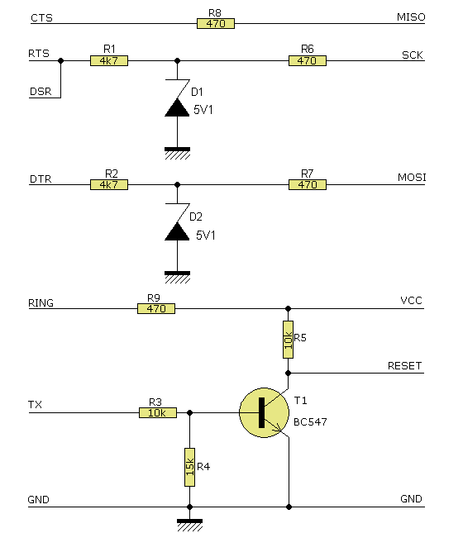
Seriell: STK200
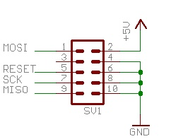
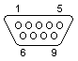
9 PIN SUB-D Stift am Rechner

Pin | Name | Beschreibung
1 | CD | Carrier Detect
2 | RXD | Recieve Data
3 | TXD | Transmit Data
4 | DTR | Data Terminal Ready
5 | GND | System Ground
6 | DSR | Data Set Ready
7 | RTS | Request to Send
8 | CTS | Clear to Send
9 | RI | Ring Indicator

8

7

6

4

1?

3

5

Original parallel:

