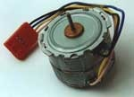
Mini-motor paso a paso "AEG S021/24"
[p5337]
Approx. 24 pasos / rotacion. 4 conexiones, approx. 8 Ohm per winding. Voltaje operativo approx. 5V / 625mA. Dimensiones sin eje ø approx. 35 x 25mm. Eje ø approx. 1 x 10mm

