OPERATING MANUAL

SIN9020P
Voltage Meter

Check the box
When you get a new SIN9020S voltage meter, it is recommended that you follow the following steps to inspect the instrument.
1. Check for damage caused by transportation.
If found packaging cartons or bubble bag cushions serious damage, keep them until the completeness and pass the test.
2. Check the box in the article are complete.
The contents of the box below. If the content does not match or if the instrument is damaged, contact your dealer or manufacturer.
Host:
SIN90100S (including headers and display power expansion board) 1
Accessories:
User Manual (pdf version) 1
3, check the machine.
Inspect the instrument is damaged, not working properly, or fails performance tests, please contact your dealer or manufacturer

Chapter 1 Overview
First,Introduction instrument
SIN90100P voltage meter is able to measure voltage, current, charge capacity, time, and other physical quantities of the new voltage meter, but also can set parameters to achieve overvoltage protection, overcurrent protection, over power protection, overcharge protection and limit capacity protection and other protection. The instrument uses color liquid crystal display measured data, display information comprehensive and humane. This instrument is ideal for monitoring the output voltage and current, as well as the battery charge and discharge applications.

Second,the main characteristics of

1, color liquid crystal display, the display interface clear fashion.

2, power and memory function, power failure after the number of memory before power can be AH, facilitate the observation and measurement.

3, time and number of AH clear function, does not affect the measurement.

4, voltage, current, charge capacity, power, or simultaneous display time, display clear and comprehensive information.

5, with an output shutdown function keys, flexible output turned on or off.

6, with overvoltage, undervoltage, overcurrent, limit, overcharge protection.

7, online calibration, enabling customers to promptly correct the error.

Third，technical indicators
Project |  | Parameters
Voltage measuring range | Self-powered voltage measurement range | 10V~90V
 | External power measurement range | 0~90V
Current input \ output current measurement range |  | 0~20A
Display method |  | Color liquid crystal display
Display Resolution | Voltage | 0.01V
 | Current | 0.01A
 | Capacity | 0.01AH
 | Time | 1min
Accuracy | Voltage | 1% + 2 words
 | Current | 2% + 5 words
Measurement rate |  | 5 times / sec
Dimensions (length × width × height) |  | 79×43×52（mm）
Mounting hole opening (mm) |  | 76.5*39.2（mm）

Chapter II Instrument Description

First, the Panel

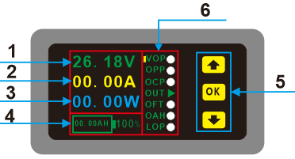
Figure 2-1 Front Panel
grade | explain
1 | voltage value  Current value  Time value  Capacity value  Key  Parameter setting display area
2 | current value
3 | time value
4 | capacity value
5 | key
6 | parameter setting display area
Front Panel Description Table 2-1 SIN9020P

Second, wiring

Behind SIN9020 voltage meter has four terminals, "OUT -", "VCC +", "Vext +", "IN -", where "Vext +" positive external power supply terminals when three-wire system. "VCC +" to the positive input positive power supply, but also the load.

This paragraph header in two-wire system and three-wire connection, two-wire instrument can be directly plugged in, the three-wire system requires an external power supply separately for the instrument.

1, meter two-wire connection diagrams and instructions

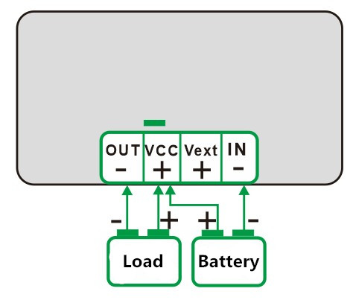
Figure 2-4 Two-wire wiring diagram

Two-wire connection:

Positive power of the positive electrode and the load connected to the common terminal "VCC +", the negative power source connected to the "IN-", the negative electrode connected to the "OUT-", pay attention to the positive and negative direction wiring load, be careful not reversed.

2, three-wire meter wiring diagram and description
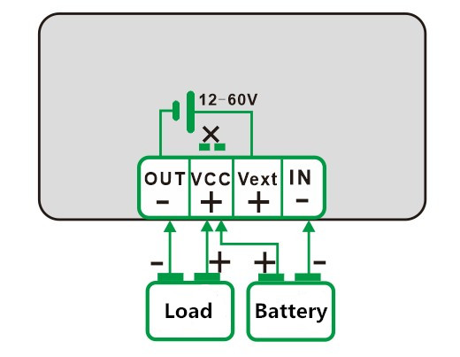

Figure 2-5 Three-wire relay wiring diagram is not connected

Three-wire connection:

Open the instrument cover, the short-circuit point with a soldering iron to pick apart the positive external power supply connected to the "Vext +", the negative external power supply connected to the "IN-", and then the cathode will load connected to the "VCC +", load the negative electrode connected to the "OUT-" on the positive power of the knot "VCC +", the negative electrode connected to the "IN-", the attention to positive and negative direction wiring, be careful not reversed.

Chapter III Instructions

First wiring

Select the appropriate wiring based on the measured voltage, ensure that the input voltage is within the tolerance range of the instrument.

Note: self-powered input voltage range: 10V ~ 90V;

External power supply input voltage range: 0V ~ 90V.

Second, the protection function setting

If you want to open a certain protection, move the yellow cursor to the item, click on the OK button will set the corresponding entry lights turn green if the protection is set to shut down the gray protection. Before turning on the protection must first set the protection parameters, the method is long press the OK button for three seconds or so to enter the protection parameters settings page, and then by adjusting the keys to increase or decrease the parameter settings. Setting parameters When finished, click OK to return to the initial interface, default parameters for each function of the factory are 000.

NOTE: If you have not adjusted after entering protected parameter adjustment page parameters, need to click in the press, click on the OK button to return to the original page.

Third, protection Features

1, "OVP" over-voltage protection, if set OVP value and the OVP protection options open, when the input voltage exceeds the set voltage, the unit will automatically cut off the output, and the light from green to gray-OUT . Want to restore output shutdown protection, the yellow cursor to "OUT", click the OK button to open the new output.

2, "OPP" is over power protection, if you set the value of OPP and the OPP protection options open, when the output power exceeds the power, the machine will automatically cut off the output, and the light from green to gray-OUT . Protection shutdown want to restore the output, the yellow cursor to "OUT", click the OK button to open the new output.

3, "OCP" is over-current protection, if set OCP value, and opened the OCP protection options, when the input current exceeds the set current, the machine will automatically cut off the output, and the light from green to gray-OUT . Protection shutdown want to restore the output, the yellow cursor to "OUT", click the OK button to open the new output.

4, "OFT" overtime protection, if the value is set OFT, the OFT protection options open and, when working time exceeds the set operating time, the machine will automatically cut off the output, and the OUT lights from green to gray. Protection shutdown want to restore the output, the yellow cursor to "OUT", click the OK button to open the new output.

5, "OAH" super-capacity protection, if OAH set value, and opened the OAH protection options, when the accumulated value exceeds the set AH AH value, the machine will automatically cut off the output, and the lights from green to OUT gray. Protection shutdown want to restore the output, the yellow cursor to "OUT", click the OK button to open the new output.

Percentage of the capacity of the display is the actual measured value and the set number of AH compared: the percentage of capacity = (actual number AH / AH set number) * 100%.

6. Move the cursor to "OUT" place, press OK to enter the charge and discharge mode switch interface, by adjusting the number keys to change AH ​​explicit mode. If "Discharge" discharge mode, the percentage of capacity will gradually decrease. If "Charging" charge mode, the percentage of capacity will be gradually increased. Note: The first set AH percentage will be displayed properly.

7, "LOP" under-voltage protection, if you set the LOP values ​​and opens the LOP protection options, when the input voltage exceeds the set voltage, the unit will automatically cut off the output, and the light from green to gray-OUT . Protection shutdown want to restore the output, the yellow cursor to "OUT", click the OK button to open the new output.

8, AH number and time clear function. The yellow cursor to "OVP" on, then press the key, so that the capacity of the display mode when the progress bar, and then click the OK button, you can clear the time, or the number of AH can be cleared or fill.

Fourth, expand Display Description

1, the third line of the default boot display of power, if you want a third line shows the time, the yellow cursor to "LOP", then press the key again to switch the display content.

2, the default boot battery capacity percentage, if you want to display real-time capacity, it will move the yellow cursor to "OVP" and then press to switch the display content.

Care and maintenance

1, can not exceed the voltage and current range of the instrument, otherwise it will damage the instrument.

2, positive and negative can not be reversed, reverse can not be measured correctly.

3, the working temperature of -10 ~ 50 ℃, Storage temperature -20 ~ 70 ℃, and the instrument in a dry environment.

4. Do not attempt to disassemble the instrument, destroy the package will void the warranty. This instrument there are no user-serviceable parts, repairs may only be designated repair outlets or by returning the factory.

5, please do not move the instrument to avoid severe irreparable damage to the internal circuit when the instrument is working properly.

Warranty and service

Thank you for purchasing the sinusoidal electronic products. To maximize the use of your new product features, we recommend that you take the following a few simple steps:

1. Read the safety and efficient use.

2, read the warranty terms and conditions.

Warranty conditions:

From the date of shipment from the instrument warranty for one year. During the warranty period, the company's failure to repair or replace the instrument selected according to the situation. For service, please send the product to our company.

Warranty does not cover the following cases:

User operation or damage caused by improper maintenance; or use the software to provide their own user interfaces; service center without authorization, disassemble or repair damage caused.

