How calculate transformer over Amidon toroids

Example of an impedance adaption from 330 Ohms to 500 Ohms at an IF Freq. of 10.7 MHz.

- Calculate the input inductance from the input impedance at a given Freq.
Z 330 Ohm @ 10.7MHz -> 4.92 uH
Quelle:http://www.learningaboutelectronics.com/Articles/Inductor-impedance-calculator.php#answer

- Calculate the primary turns over an Amidon from known primary inductance
4.92 uH -> 30 turns over a T-30-2 (Red) Amidon Toroid
Quelle1: http://www.66pacific.com/calculators/toroid-coil-winding-calculator.aspx
Quelle2: 34 turns with Miniring Core Calculator
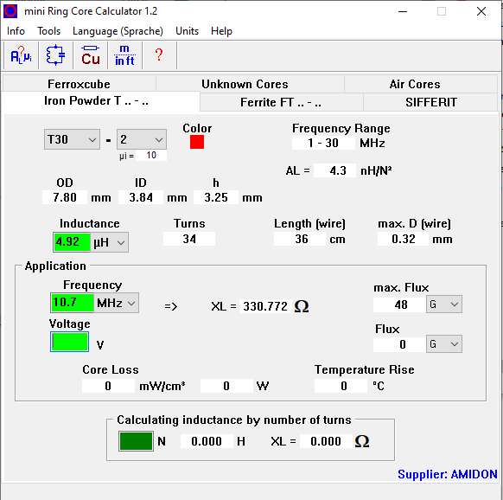

- Calculate the secondary turns from a known secondary impedance (Z sec), primary impedance (Zpri) & primary turns

Zpri 330 Ohm, Zsec 500 Ohm, 30 (-34) turns on primary ->
Turns ratio 1: 1.231, turns secondary 37 (-42)
Qulle1: http://www.maxmcarter.com/classecalcs/tratiocalc.html
Quelle 2: 42 turns with Miniring Core Calculator
