Bluetooth Serial Adaptor

User’s Manual
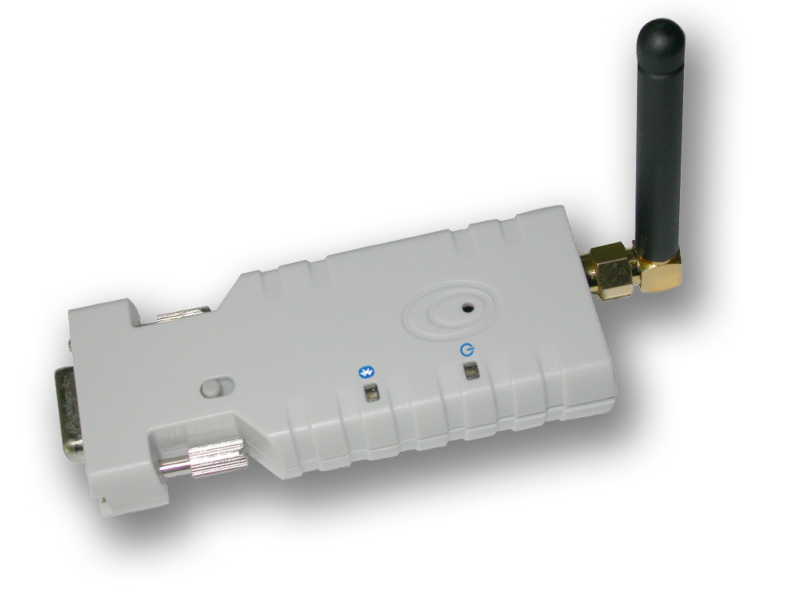

Wireless Solutions in Your Hand

TABLE OF CONTENTS

1. INTRODUCTION…………………………………………………3
1.1. Features………………………………………………………… 3
1.2. Package……………………………….…………...……………3
2. SPECIFICATIONS……………………………………….……...3
2.1. General………………………...……………………………….3
2.2. RS232 Interface………………….........................................4
2.2.1. Pin-out………………………………………………………4
2.2.2. Signals………………………….....................................4
2.3. Factory Settings………………………………………..............4
3. INSTALLATION……………………………………………………4
3.1. Hardware Structure...…………………………………………..4
3.1.1. Reset Button……………………………………………..4
3.1.2. Slide Switch ………………………………………………4
3.1.3. Power Supply …………………………………………….5
3.1.4. LED Status……………………………………………..... 5
3.2 Installation Procedure………………………………………….5
4. USAGE…………………………………………………………….5
4.1 HyperTerminal Settings………………………………………..5

4.2 Configuration…………….……………………………………..5
4.2.1. Configuration Start-up…………………………………..5
4.2.2. Master Role Configuration………………………………6
4.3 AT Command Set………………………………………………6
-2-

1. Introduction
Thank you for purchasing our Bluetooth serial adaptor. The adaptor eliminates your conventional RS232 serial cables, providing an easy-to-use, invisible connection with superior freedom of movement. This tiny adaptor allows any device with a standard 9-pin serial port to communicate wirelessly. You can communicate with another Bluetooth serial adaptor or other Bluetooth-enabled devices such as a laptop computer, PDA or mobile phone.
1.1. Features
- Supports Bluetooth Serial Port Profile and Generic Access Profile
- No need of external host and software
- Easy of installation and use
- Supports configuration of the local device
- Easy of maintenance
- Supports up to 100 meters (line of sight)
1.2. Package
- Bluetooth serial adaptor: 1 ea
- Antenna: 1 ea
- DB9 male to female converter: 1 ea
- USB cable for power supply: 1 ea
- DC adaptor: 1 ea
- User’s manual: 1 ea
2. Specifications
2.1. General
Specification | Description
Baud Rate | Supports 4.8/9.6/19.2/38.4/57.6/115.2/230.4 Kbps
Coverage | Up to 100 m
Connection | Point-to-point (pico net)
Signal | TxD, RxD, GND, CTS, and RTS
RS-232 Interface | D_SUB 9-pin female
Standard | Bluetooth specification version 2.0+EDR
Frequency | 2.400 to 2.4835 GHz
Hopping | 1,600/sec, 1MHz channel space
Modulation | GFSK-1 Mbps, DQPSK-2 Mbps, and 8-DPSK-3 Mbps
Tx. Power | Max. 18 dBm (Class 1)
Rx. Sensitivity | -86 dBm typical
Antenna | Chip antenna or SMA female + external antenna (optional)
Antenna Gain | Chip antenna max. 1 to 2 dBi
Power Supply | +5 to +6 V DC
Current Consumption | Max. 90 mA
Operation Temperature | -20°C to +75°C
Dimensions | 35 mm (W) x 65 mm (D) x 16 mm (H)

-3 -

2.2. RS232 Interface
2.2.1. Pin-out

2.2.2. Signals
Pin | Signal | DTE  Direction | DCE  Direction | Description
1 | CD | Input | Output | Not connected
2 | TxD | Output | Input | Transmitted data
3 | RxD | Input | Output | Received data
4 | DSR | Input | Output | Not connected
5 | GND | N/A | N/A | Signal ground
6 | DTR | Output | Input | Not connected
7 | CTS | Input | Output | Clear to send (Remarks)
8 | RTS | Output | Input | Request to send (Remarks)
9 | Vcc | Input | Input | Power supply
Remarks: The default hardware configuration is for using CTS/RTS. If you want to use DSR/DTR, please contact us.
2.3. Factory Settings
The factory settings of COM port are as follows:
- Baud rate: 19200 bps
- Data bit: 8
- Parity: none
- Stop bit: 1
- Flow control: H/W or none
- Others: Please refer to section 4.3 AT Command Set.
3. Installation
3.1. Hardware Structure
The figure below is an outline of the adaptor.
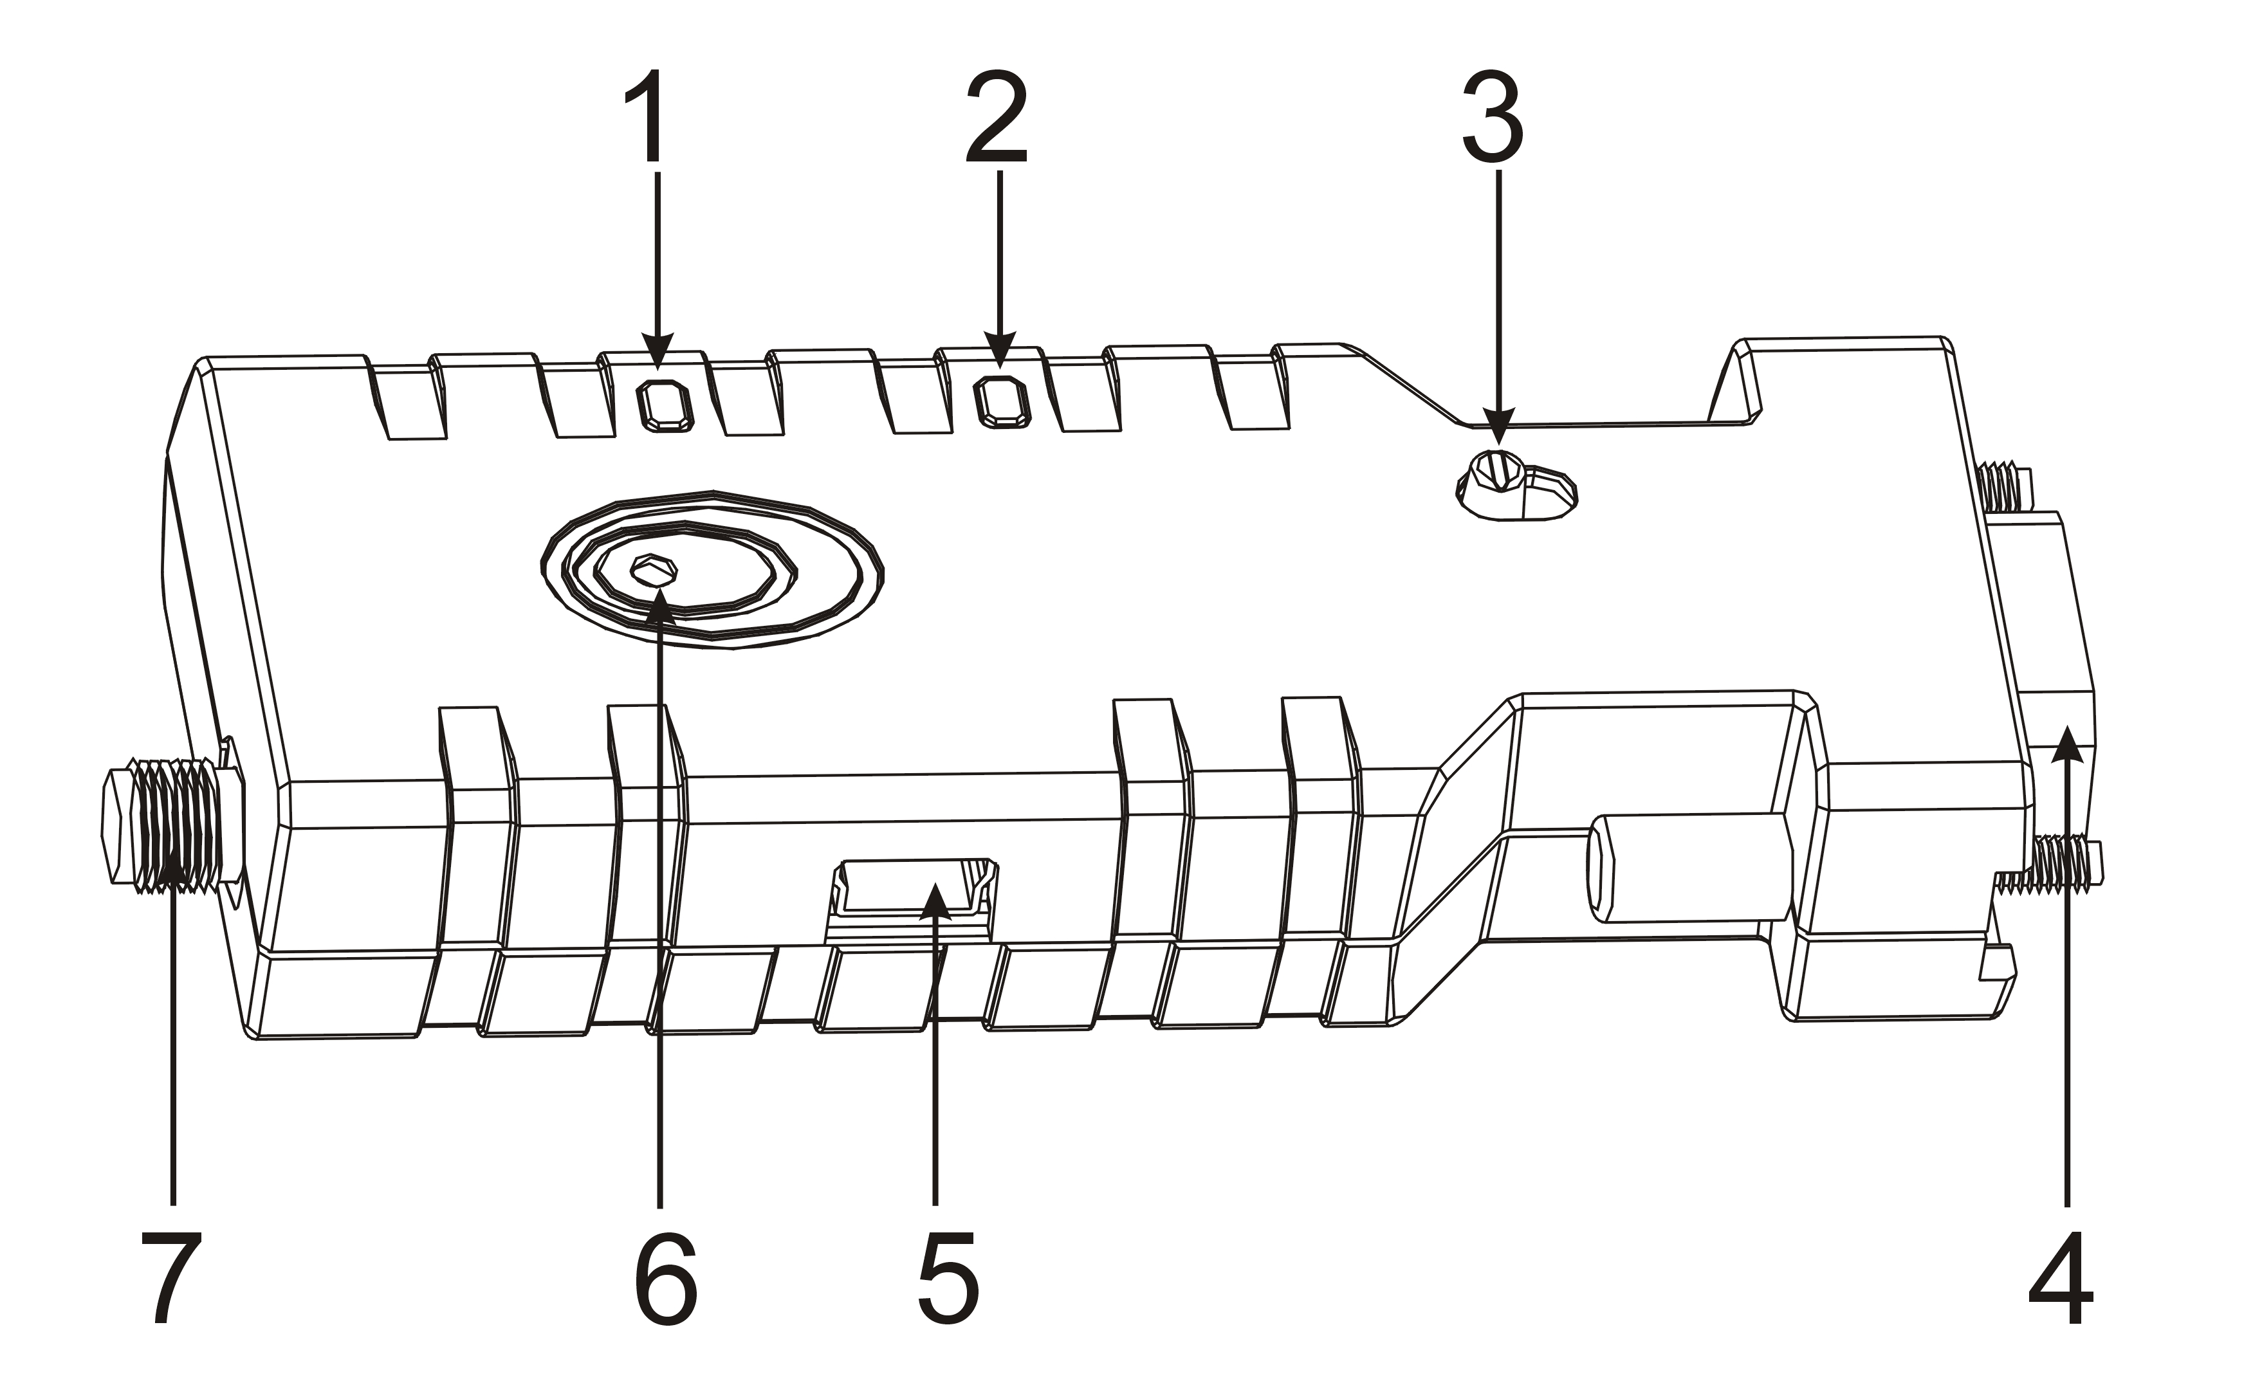
1 Power LED | 2 Link LED | 3 Slide switch | 4 RS232 connector
5 Mini USB Connector | 6 Reset button | 7 Antenna connector
3.1.1. Reset Button
By pressing the Reset button, you can:
- Disconnect and reconnect a wireless connection (after a short press).
- Restore the factory settings (after over three seconds' press).
3.1.2. Slide Switch
The slide switch can swap TXD/RXD and CTS/RTS signals.
By switching, you can set the adaptor either as a DTE (towards antenna connector) or a DCE (towards RS232 connector).
- 4 -

that the baud rate is incorrect. Ensure that the baud rate is 19200 bps.
Step 7: Input "AT", and then press <Enter>. "OK" is displayed.
If necessary, reprogram the configuration of adaptor using AT commands. For related commands, please refer to section 4.3 AT Command Set.
4.2.2 Master Role Configuration
You can use "ATR0" to change the adaptor to the master role.
When the adaptor is in the master role, you can use "ATO1" to manually set up a connection and "ATF?" to find the device you want to connect.

AT Command Set
The following is the AT command set for the local adaptor in the command mode
(that is, the local adaptor is in the disconnection state). All the commands and
parameters are case insensitive.
Command |  | Description
A |  | This command is used to establish a connection.  It is available only when the adaptor is in the master role.
 | A | Connect the adaptor to a specified Bluetooth device.  It is available only when "ATD=xxxxxxxxxxxx" is executed.
 | A1-A8 | Connect the adaptor to a Bluetooth device in the neighborhood found through "ATF?"
B |  | This command is used to display the Bluetooth address of the local adaptor.
 | B? | Inquire the Bluetooth address of the local adaptor.
C |  | This command enable or disable flow control signals (CTS/RTS) of the UART port. Note, the setting is not affected by ATZ0
 | C0 | Disable flow control.
 | C1 (Default) | Enable flow control.
 | C? | Inquire the current setting
D |  | For security purpose, this command is used to specify a unique remote Bluetooth serial adaptor to be connected.  In the master role, the adaptor pairs and connects with the designated remote slave address.  If the adaptor is in the slave mode, this command is a filter condition to accept the inquiry of the master device.
 | D=xxxxxxxxxxxx | "xxxx-xx-xxxxxx" is a string of 12 hexadecimal digits.
 | D0 | Restore the status in which the adaptor can connect with any remote address.
 | D? | Inquiry the designated address that can be paired and connected.
-6 -
3.1.3. Power Supply
The adaptor can be powered via:
- An AC/DC converter (output power: +5 to +6 V DC/300 mA)
- A USB cable
- Pin 9 of the D SUB 9-pin connector
3.1.4. LED Status
The following is LED status information.
Status | Description
Power LED off | No power supply.
Power LED on | Firmware is running OK.
Link LED off | No pairing established.
Link LED fast (0.1 sec) blinking | Pairing (slave or master mode).
Link LED fast (0.3 sec) blinking | Discoverable and waiting for a  connection (slave mode).
Link LED slow (0.9 sec) blinking | Inquiring (master mode).
Link LED very slow (1.2 sec) blinking | Connecting (master mode).
Link LED steadily on | Connection established.
3.2. Installation Procedure
Step 1: If provided with an external antenna, assemble it to the adaptor body.
Step 2: Plug the adaptor into the COM port of device.
Step 3: Adjust the slide switch, depending on whether the device is a DTE or DCE.
Step 4: Power the adaptor on.
Step 5: Configure the adaptor if necessary.

4. Usage
You can reprogram the default settings on the adaptor using HyperTerminal.

4.1 HyperTerminal Settings
- Bits per second: 19200 bps (baud rate)
- Data bit: 8
- Parity: None
- Stop bit: 1
- Flow control: H/W

4.2 Configuration
4.2.1 Configuration Start-up
Step 1: Plug the adaptor into a COM port of PC.
Step 2: Power the adaptor on.
Step 3: Create a HyperTerminal file.
Step 4: On the interface of the new HyperTerminal file, click Properties button.
Step 5: Select the COM port where the adaptor is attached to your PC and set the port properties as described in section 4.1 HyperTerminal Settings.
Step 6: Input "A" in the file and then press <Enter>.
If no echo, that is, nothing is displayed when you input "A", it indicates
-5 -

Command |  | Description
E |  | This command is used to specify whether the adaptor echoes characters received from the UART back to the DTE/DCE.
 | E0 | Command characters received from the UART are not echoed back to the DTE/DCE.
 | E1 (default) | Command characters received from the UART are echoed back to the DTE/DCE.
 | E? | Inquire the current setting.
F |  | This command is used to search for any Bluetooth device in the neighborhood within one minute. If any device is found, its name and address will be listed. The search ends with a message "Inquiry ends. xx device(s) found."  This command is available only when the adaptor is in the master role.
 | F? | Inquire Bluetooth devices in the neighborhood, listing 8 devices the maximum
H |  | This command is used to specify whether the adaptor can be discovered or connected by remote devices.
 | H0 | The adaptor enters the undiscoverable mode. If a pair has been made, the original connection can be resumed. But other remote master device cannot discover this adaptor.
 | H1 (default) | The adaptor enters the discoverable mode.
 | H? | Inquire the current setting.
I |  | This command is used to inquiry the firmware version.
 | I? | Inquire the version codes.
K |  | This command is used to specify one or two stop bits of COM port.
 | K0(default) | One stop bit.
 | K1 | Two stop bits.
 | K? | Inquire the current setting.
L |  | This command is used to specify the baud rate of COM port.
 | L0 | 4800 bps
 | L1 | 9600 bps
 | L2 (default) | 19200 bps
 | L3 | 38400 bps
 | L4 | 57600 bps
 | L5 | 115200 bps
 | L6 | 230.4 Kbps
 | L? | Inquire the current baud rate.
- 7 -
Command |  |  |  | Description
M |  |  |  | This command is used to specify parity bit setting of COM port.
 |  |  | M0(default) | None parity bit.
 |  |  | M1 | Odd parity.
 |  |  | M2 | Even parity
 |  |  | M? | Inquire the current setting.
N |  |  |  | This command is used to specify a name for the adaptor.  You can specify a friendly name using 0 to 9, A to Z, a to z, space and –, which are all valid characters. Note that "first space or -, last space or – isn’t permitted". The default name is “Serial Adaptor”.
 |  | N=xxxxxx |  | "xxxxxx" is a character string with a maximal length of 16.
 |  | N? |  | Inquire the name of the local adaptor.
O |  |  |  | This command is used to enable/disable auto-connection feature.  It is available only when the adaptor is in the master role.
 |  | O0 (Default) |  | Automatically connect the adaptor to a device specified by "ATD" or any available device if "ATD=xxxxxxxxxxxx" is not executed.
 |  | O1 |  | Disable auto-connection feature. After it is executed, you need to execute "ATA" to manually connect a remote device.
 |  | O? |  | Inquire the current setting.
P |  |  |  | This command is used to specify a PIN. The default PIN is "1234". Paired adaptors should have a same PIN.
 |  | P=xxxxxxx |  | "xxxx" is a 4~8-digit string.
 |  | P0 |  | Cancel authentication by PIN.
 |  | P? |  | Inquire the current PIN.
Q |  |  |  | The command is used to decide whether result messages are prompted when AT commands are executed.  The result messages are: OK/ERROR for command execution, or CONNECT/DISCONNECT for connection status.
 | Q0 (default) |  |  | Prompt result messages.
 | Q1 |  |  | Not prompt result messages.
 | Q? |  |  | Inquire the current setting.
R |  |  |  | This command is used to specify whether the adaptor is in the master or slave role.  If the device role is changed, the adaptor will reboot and all paired addresses will be cleared.
 |  | R0 |  | Set the adaptor to the master role.
 |  | R1 (default) |  | Set the adaptor to the slave role.
 |  | R? |  | Inquire the current role of the adaptor.
Z |  |  |  | This command is used to restore the default settings and originate a warm start.
 |  | Z0 |  | Restore the default settings (e.g. 19200 bps).
- 8 -
Command |  |  |  | Description
M |  |  |  | This command is used to specify parity bit setting of COM port.
 |  |  | M0(default) | None parity bit.
 |  |  | M1 | Odd parity.
 |  |  | M2 | Even parity
 |  |  | M? | Inquire the current setting.
N |  |  |  | This command is used to specify a name for the adaptor.  You can specify a friendly name using 0 to 9, A to Z, a to z, space and –, which are all valid characters. Note that "first space or -, last space or – isn’t permitted". The default name is “Serial Adaptor”.
 |  | N=xxxxxx |  | "xxxxxx" is a character string with a maximal length of 16.
 |  | N? |  | Inquire the name of the local adaptor.
O |  |  |  | This command is used to enable/disable auto-connection feature.  It is available only when the adaptor is in the master role.
 |  | O0 (Default) |  | Automatically connect the adaptor to a device specified by "ATD" or any available device if "ATD=xxxxxxxxxxxx" is not executed.
 |  | O1 |  | Disable auto-connection feature. After it is executed, you need to execute "ATA" to manually connect a remote device.
 |  | O? |  | Inquire the current setting.
P |  |  |  | This command is used to specify a PIN. The default PIN is "1234". Paired adaptors should have a same PIN.
 |  | P=xxxxxxx |  | "xxxx" is a 4~8-digit string.
 |  | P0 |  | Cancel authentication by PIN.
 |  | P? |  | Inquire the current PIN.
Q |  |  |  | The command is used to decide whether result messages are prompted when AT commands are executed.  The result messages are: OK/ERROR for command execution, or CONNECT/DISCONNECT for connection status.
 | Q0 (default) |  |  | Prompt result messages.
 | Q1 |  |  | Not prompt result messages.
 | Q? |  |  | Inquire the current setting.
R |  |  |  | This command is used to specify whether the adaptor is in the master or slave role.  If the device role is changed, the adaptor will reboot and all paired addresses will be cleared.
 |  | R0 |  | Set the adaptor to the master role.
 |  | R1 (default) |  | Set the adaptor to the slave role.
 |  | R? |  | Inquire the current role of the adaptor.
Z |  |  |  | This command is used to restore the default settings and originate a warm start.
 |  | Z0 |  | Restore the default settings (e.g. 19200 bps).
- 8 -

