Start with ESP32-CAM
I use Arduino IDE test my new toy, an ESP32-CAM, now I’ll show you how to start with it.
First of all, we need get ready our hardware：
- An ESP32-CAM dev board
- A camera, like OV2640 or OV7670, I use the OV2640 for test
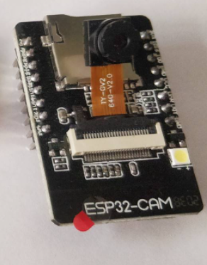
Ps:I think the OV2640 for test, the OV7670 better for projects

3、TTL to USB module
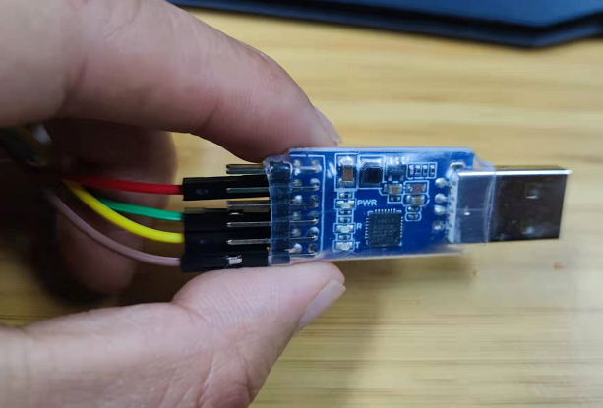

Next step, software part:
Arduino IDE(https://www.arduino.cc/en/software/)
There are Arduino IDE for Windows, for Linux and for Mac OS

Step 3
Put your ESP32-CAM link to TTL to USB module
TTL to USB 5V link ESP32-CAM 5V
TTL to USB GND link ESP32-CAM GND
TTL to USB TXD link ESP32-CAM U0R
TTL to USB RXD link ESP32-CAM U0T
Like this:
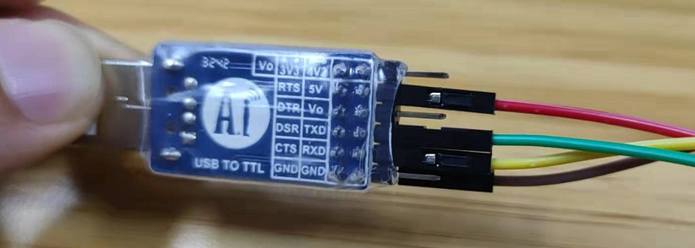
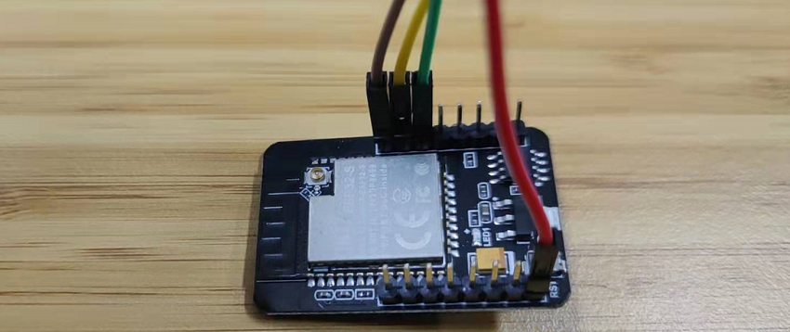

Step 4
Take your TTL to USB module into USB interface of your computer, and open your PC Manage——Device Manager——Ports, remember your COM
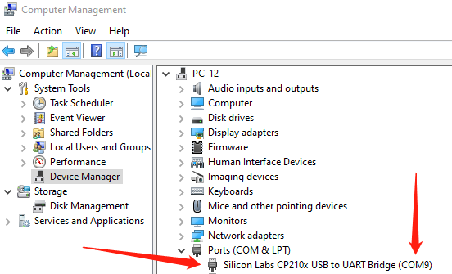
Step 5
Open your Arduino IDE, File——Preferences, take https://dl.espressif.com/dl/package_esp32_index.json into Additional Boards Manager URLs
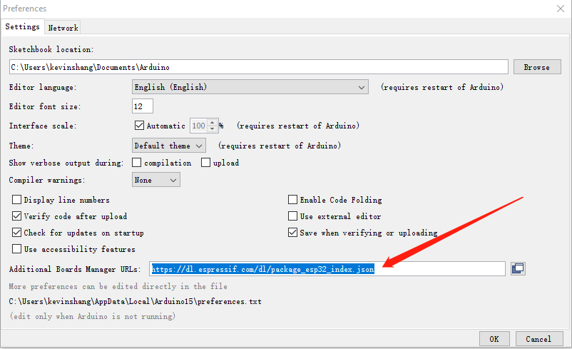

Step 6
Click Tools, find Board, choose AI Thinker ESP32-CAM, find CPU Frequency, choose 160MHz(WiFi/BT), find Port, choose your own COM(in Step 4)
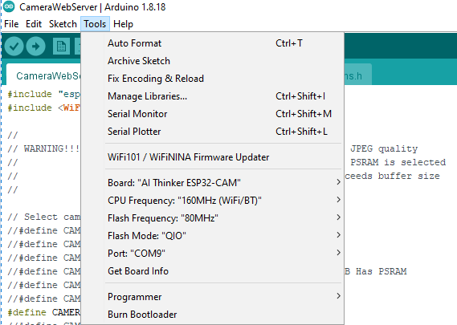
Step 7
Click File——Examples——WiFi——WiFiScan
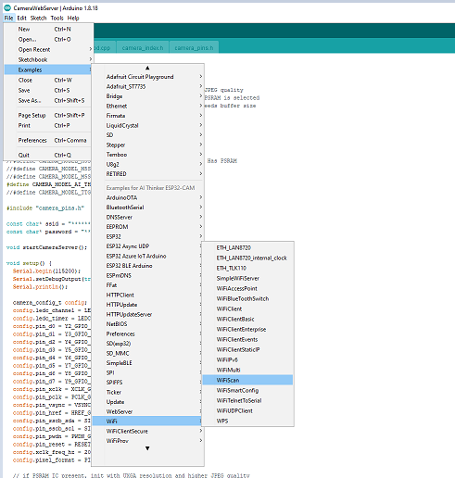

Step 8
Remove // in front of #define CAMERA_MODEL_AI_THINKER
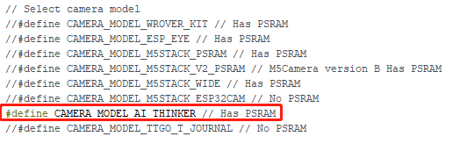

Step 9
Put your ssid and password into here
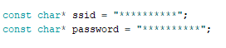
Step 10
Link IO0 and GND of your ESP32-CAM(important)
Upload the code to your ESP32-CAM dev board
Remove IO0 to GND jumper wire
Open Tools——Serial Monitor, you can find a IP address, copy it and paste in your browser
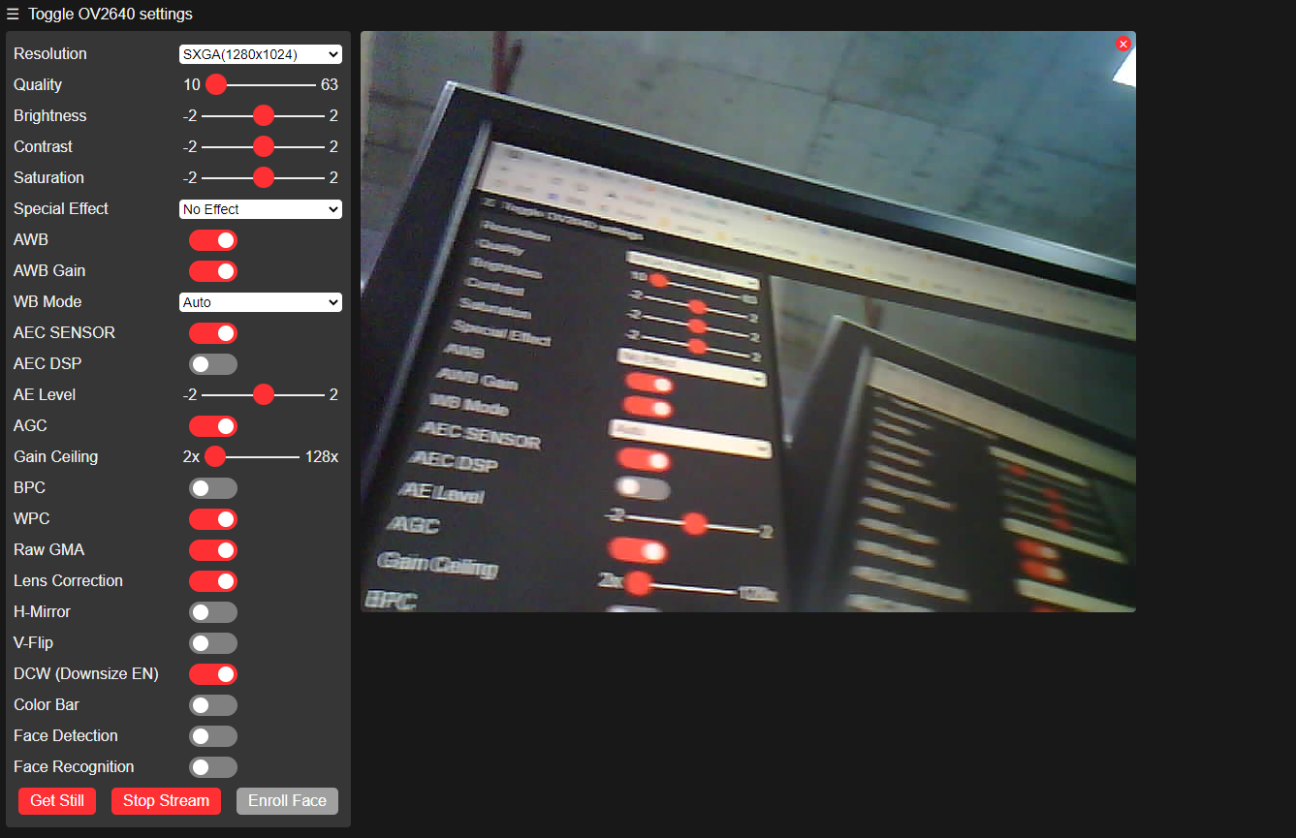
You can use your camera now, if you want Face Detection, Resolution must be CIF(400x296)
Enjoy it and share it to your friends

