GP36-S5050-RGB

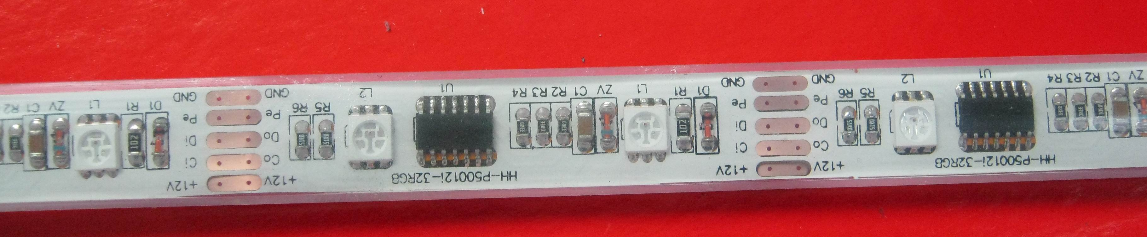
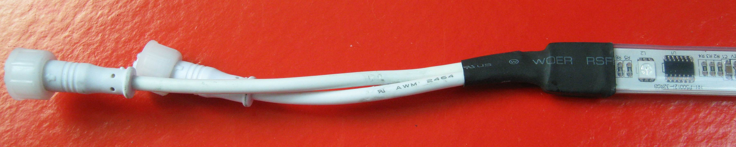


Features: Attention:
5000MM*14MM*7MM WATERPROOF LED MOD OBSERVE PRECAUTIONS WORKING BOLTAGE: 12 VDC ELECTROSTATIC
WORKING CURRENT:3600MA DISCHARGE
LED VIEW ANGLE(2θ1/2)：140 SENSITIVE
WATER PROOF: IP67 DEVICES
BUILD IN PWM SIGNAL GENERATOR IC FOR HANDLING
COLOR CHANGES

Package Dimensions

Notes : 1. All dimension units are millimeters.
2. All dimension tolerance is ±1mm unless otherwise noted

Connection diagram

Parameter | Symbol | Absolute Maximum Rating | Unit
Forward Current | IF | 3600 | mA
Power Dissipation | PD | 43.2 | W
Electrostatic discharge | ESD | 1000 | V
Operating Temperature | Topr | -25∽+60 | ℃
Storage Temperature | Tstg | -40∽+80 | ℃

Parameter | Symbol | Condition |  | Min | Typ | Max | Unit
Forward Voltage DC | VF | IF=3600mA |  | --- | 12 | --- | V
Dominant Wavelength | λD | IF=3600mA | R | 620- |  | 625 | nm
Dominant Wavelength | λD | IF=3600mA | G | 515 |  | 520 | nm
Dominant Wavelength | λD | IF=3600mA | B | 465 |  | 470 | nm
Luminous flux | φV | IF=3600mA |  | --- | --- | --- | lm
Recommend Forward Current | IF(rec) |  |  | --- | 3600 | --- | mA

