TI Vorlagen, Targeteinstellungen und Fehler
- CCS Build Example_2803xEPwmUpDownAQ (executable, GenerichDevice C28xx, Tiv5. 2. 9, automatic)
Targetconfigurationen a)Connection: TI XDS 100v2 USB Emulator Board or Device: Developer´s Kit – Dual Motor Control and PFC (F28035) 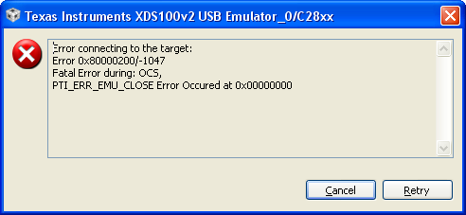 b) Connection: TI XDS 100v2 USB Emulator Board or Device: Developer´s Kit Motor Control and PFC(F28035) 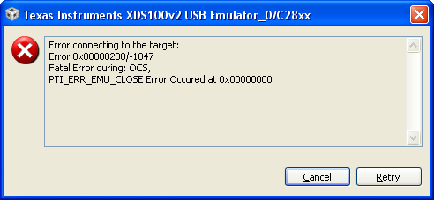
c) Connection: TI XDS 100v2 USB Emulator Board or Device: Experimetier´s Kit Picolo F28035 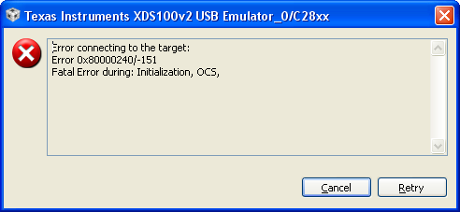
d) Connection: TI XDS 100v2 USB Emulator Board or Device: TMS320F28035
2) CCS Build Example_2803xEPwmUpDownAQ (executable, GenerichDevice C28xx, Tiv5. 2. 9, automatic)
Targetconfigurationen: a)Connection : TI XDS 100v1 USB Emulator Board or Device: Developer´s Kit – Dual Motor Control and PFC (F28035) 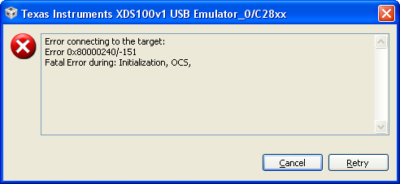
b) Connection : TI XDS 100v1 USB Emulator Board or Device: Developer´s Kit –Motor Control and PFC (F28035) 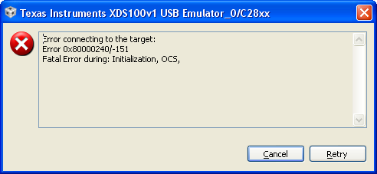
c) Connection : TI XDS 100v1 USB Emulator Board or Device: Experimetier´s Kit Picolo F28035
d) Connection : TI XDS 100v1 USB Emulator Board or Device: TMS320F28035
3) CCS Build Example_2803xEPwmUpDownAQ (executable, GenerichDevice C28xx, Tiv5. 2. 9, automatic) Targetconfigurationen a)Connection : TI Simulator Board or Device : C64xx 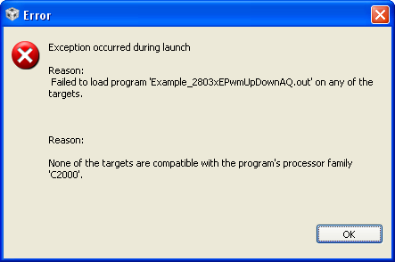 b) Connection : TI Simulator Board or Device : C67xx Little Endian 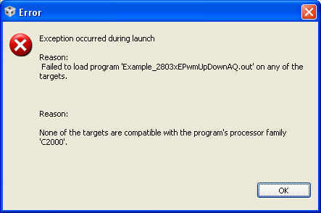
4) Das Kit läuft und mit dem PC kommuniziert. a) CCS Build b)Targetconfigurationen Connection : TI XDS100v2 USB Emulator Board or Device : TMS320F28035 